**1. INTRODUCTION ABOUT THE PROJECT**

The aim of this project is to design, build a Computer Science Department, Enterprise Resource Planning Software. This will be a vastly complex software development project which will take approximately 5 months to complete. The project will be split up into stages and documented thoroughly throughout.

Project management is a key factor of this task to ensure the strict deadlines are adhered to. It is also of paramount importance that tried and tested practices and techniques from the field are adhered to ensure that no common development project mistakes are reproduced.

**2. OBJECTIVE**

Objective of the project is described by comparing with the existing system as explain below.

The current system is unable to handle any of the day to day tasks of the department. The current system does not provide any functionality to ease the work for either of the interested parties. Thus the current system thus leaves a huge room for improvement. The aim of the proposed system is to develop a system of improved facilities. The proposed system provides a wide set of functionalities to different users described in detail later on. The proposed system is being tailored according to the needs of the users by surveying them and their needs.

PROPOSED SYSTEM VS EXISTING SYSTEM

* Reduction of Carbon footprint.
* A transparent and clearer view of the system.
* Easier access and management.
* To reduce communication gap between teachers and the students.
* Develop and encourage use of Discussion forum amongst students.
* Reduce time consumption.
* Reduce error scope.

3. SYSTEM ANALYSIS

System analysis is a process of gathering and interpreting facts, diagnosing problems and the information to recommend improvements on the system. It is a problem solving activity that requires intensive communication between the system users and system developers. System analysis or study is an important phase of any system development process. The system is studied to the minutest detail and analyzed. The system analyst plays the role of the interrogator and dwells deep into the working of the present system. The system is viewed as a whole and the input to the system are identified. The outputs from the organizations are traced to the various processes. System analysis is concerned with becoming aware of the problem, identifying the relevant and decisional variables, analyzing and synthesizing the various factors and determining an optimal or at least a satisfactory solution or program of action.

**3.1 Existing System**

In the existing system only we can see the details of particular information about department in our college, the existing system has more workload for the authorized person, but in the case of Proposed System, the user can registered in our site and send the department related details.

**3.2 Drawbacks of Existing System**

* More man power.
* Time consuming.
* Consumes large volume of pare work.
* Needs manual calculations.
* No direct role for the higher officials.
* Damage of machines due to lack of attention.

To avoid all these limitations and make the working more accurately the system needs to be

Computerized.

**3.3 Proposed System**

The aim of proposed system is to develop a system of improved facilities. The proposed system can overcome all the limitations of the existing system. The system provides proper security and reduces the manual work. The existing system has several disadvantages and many more difficulties to work well. The proposed system tries to eliminate or reduce these difficulties up to some extent. The proposed system will help the user to reduce the workload and mental conflict. The proposed system helps the user to work user friendly and he can easily do his jobs without time lagging.

**Expected Advantages of Proposed System**

The aim of proposed system is to develop a system of improved facilities. The proposed system can overcome all the limitations of the existing system. The system provides proper security and reduces the manual work. The existing system has several disadvantages and many more difficulties to work well. The proposed system tries to eliminate or reduce these difficulties up to some extent. The proposed system will help the user to reduce the workload and mental conflict. The proposed system helps the user to work user friendly and he can easily do his jobs without time lagging.

**Expected Advantages of Proposed System**

The system is very simple in design and to implement. The system requires very

low system resources and the system will work in almost all configurations. It has got following features

* Ensure data accuracy’s.
* Proper control of the higher officials.
* Reduce the damages of the machines.
* Minimize manual data entry.
* Minimum time needed for the various processing.
* Greater efficiency.
* Better service.
* User friendliness and interactive.
* Minimum time required.

**3.4.1 FEASIBILITY STUDY**

Feasibility study is made to see if the project on completion will serve the purpose of the organization for the amount of work, effort and the time that spend on it. Feasibility study lets the developer foresee the future of the project and the usefulness. A feasibility study of a system proposal is according to its workability, which is the impact on the organization, ability to meet their user needs and effective use of resources. Thus when a new application is proposed it normally goes through a feasibility study before it is approved for development.

The document provide the feasibility of the project that is being designed and lists various areas that were considered very carefully during the feasibility study of this project such as Technical, Economic and Operational feasibilities. The following are its features:

**3.4.2 TECHNICAL FEASIBILITY**

The system must be evaluated from the technical point of view first. The assessment of this feasibility must be based on an outline design of the system requirement in the terms of input, output, programs and procedures. Having identified an outline system, the investigation must go on to suggest the type of equipment, required method developing the system, of running the system once it has been designed.

Technical issues raised during the investigation are:

* Does the existing technology sufficient for the suggested one?
* Can the system expand if developed?

The project should be developed such that the necessary functions and performance are achieved within the constraints. The project is developed within latest technology. Through the technology may become obsolete after some period of time, due to the fact that never version of same software supports older versions, the system may still be used. So there are minimal constraints involved with this project. The system has been developed using Java the project is technically feasible for development.

**3.4.3 ECONOMIC FEASIBILITY**

The developing system must be justified by cost and benefit. Criteria to ensure that effort is concentrated on project, which will give best, return at the earliest. One of the factors, which affect the development of a new system, is the cost it would require.

The following are some of the important financial questions asked during preliminary investigation:

* The costs conduct a full system investigation.
* The cost of the hardware and software.
* The benefits in the form of reduced costs or fewer costly errors.

Since the system is developed as part of project work, there is no manual cost to spend for the proposed system. Also all the resources are already available, it give an indication of the system is economically possible for development.

**3.4.4 BEHAVIORAL FEASIBILITY**

This includes the following questions:

* Is there sufficient support for the users?
* Will the proposed system cause harm?

The project would be beneficial because it satisfies the objectives when developed and installed. All behavioral aspects are considered carefully and conclude that the project is behaviorally feasible.

**4. MODULES**

Design is the first step into the development phase for any engineered product or system. Design is a creative process. A good design is the key to effective system. The term “design” is defined as “the process of applying various techniques and principles for the purpose of defining a process or a system in sufficient detail to permit its physical realization”. It may be defined as a process of applying various techniques and principles for the purpose of defining a device, a process or a system in sufficient detail to permit its physical realization. Software design sits at the technical kernel of the software engineering process and is applied regardless of the development paradigm that is used. The system design develops the architectural detail required to build a system or product. As in the case of any systematic approach, this software too has undergone the best possible design phase fine tuning all efficiency, performance and accuracy levels. The design phase is a transition from a user oriented document to a document to the programmers or database personnel. System design goes through two phases of development: Logical and Physical Design.

**4.1 LOGICAL DESIGN:**

The logical flow of a system and define the boundaries of a system. It includes the following steps:

* Reviews the current physical system – its data flows, file content, volumes, Frequencies etc.
* Prepares output specifications – that is, determines the format, content and Frequency of reports.
* Prepares input specifications – format, content and most of the input functions.
* Prepares edit, security and control specifications.
* Specifies the implementation plan.
* Prepares a logical design walk through of the information flow, output, input, Controls and implementation plan.
* Reviews benefits, costs, target dates and system constraints.

**4.2 PHYSICAL DESIGN:**

Physical system produces the working systems by define the design specifications that tell the programmers exactly what the candidate system must do. It includes the following steps.

* Design the physical system.
* Specify input and output media.
* Design the database and specify backup procedures.
* Design physical information flow through the system and a physical design
* Plan system implementation.
* Prepare a conversion schedule and target date.
* Determine training procedures, courses and timetable.
* Devise a test and implementation plan and specify any new hardware/software.
* Update benefits , costs , conversion date and system constraints

**4.3 MODULE DESIGN**

**MODULE DESIGN**

* Administrator
* Teacher
* Non Teaching Staff
* Student

**The Administrator module includes,**

1. Account handling:

a.a. Adding new account of Staff member and students.

a.b. View all the present accounts.

a.c. Change account password of self account.

b. Departmental tasks:

b.a Ledger

b.a.a Add ledger

b.a.b View Ledger

b.a.c Edit Ledger

b.b. Teaching duties:

b.b.a Assign teaching duty.

b.b.b. View teaching duty.

b.b.c. Delete teaching duty.

b.c Ordinance:

b.c.a. Add Subjects

b.c.b. View Subjects.

b.c.c. Delete Subjects.

b.d Manage content:

b.d.a. Upload file.

b..d.b. Download file

b.d.c. Remove file

b.e. Additional Duties:

b.e.a Add charges.

b.e.b. View charges.

b.e.c. Delete charges.

b.f. View Marks.

b.g View Attendance.

c. Discussion forum

d. Notice Board:

d.a Add notice.

d.b. Edit Notice.

d.c. Remove Notice.

**The Teacher module includes,**

a. Academics:

a.a. Attendance:

a.a.a. View Attendance.

a.a.b. Mark Attendance.

a.b. Manage Content:

a.b.a Upload content.

a.b.b. Download content.

a.b.c. Delete content.

a.c.Examination:

a.c.a. Add Subject.

a.c.b. View Subject.

a.c.c Delete Subject

a.c.d Add Questions.

a.c.e Edit Questions.

a.c.f. Delete Questions.

a.d. View Marks.

a.e. Responsibiliities.

b. Notice Board:

b.a Add notice.

b.b. Edit notice.

b.c. Remove notice.

c. Discussion froum.

d.Account Settings:

d.a Change password.

d.b. View Profile.

**The Non Teaching Staff module includes**

a.Account Hnadling:

a.a. Add Account.

a.a.a. Add student account.

a.a.b. Add teacher account.

a.b. View Account.

a.c Change Passwords.

b. Departmental Task

b.a Ledger

b.a.a Add ledger

b.a.b View Ledger

b.a.c Edit Ledger

b.b Ordinance:

b.b.a. Add Subjects

b.b.b. View Subjects.

b.b.c. Delete Subjects.

b.d Manage content:

b.c.a. Upload file.

b.c.b. Download file

b.c.c. Remove file

c. Discussion Forum

d. Notice Board.

**The Student Module includes,**

a. Academics

a.a View Attendance.

a.b. Previous Results.

a.c. Take Test.

a.d. View Faculty information.

b. Discussion Forum.

c. Downloads.

d. Account Settings.

**4.4 INPUT DESIGN**

The input design is the link between the information system and the user. It comprises the developing specification and procedures for data preparation and those steps are necessary to put transaction data in to a usable form for processing can be achieved by inspecting the computer to read data from a written or printed document or it can occur by having people keying the data directly into the system. The design of input focuses on controlling the amount of input required, controlling the errors, avoiding delay, avoiding extra steps and keeping the process simple. The input is designed in such a way so that it provides security and ease of use with retaining the privacy. Input Design considered the following things:

* What data should be given as input?
* How the data should be arranged or coded?
* The dialog to guide the operating personnel in providing input.
* Methods for preparing input validations and steps to follow when error occur.

**OBJECTIVES**

* Input Design is the process of converting a user-oriented description of the input into a computer-based system. This design is important to avoid errors in the data input process and show the correct direction to the management for getting correct information from the computerized system.
* It is achieved by creating user-friendly screens for the data entry to handle large volume of data. The goal of designing input is to make data entry easier and to be free from errors. The data entry screen is designed in such a way that all the data manipulates can be performed. It also provides record viewing facilities.
* When the data is entered it will check for its validity. Data can be entered with the help of screens. Appropriate messages are provided as when needed so that the user will not be in maize of instant. Thus the objective of input design is to create an input layout that is easy to follow

**4.5 OUTPUT DESIGN**

* A quality output is one, which meets the requirements of the end user and presents the information clearly. In any system results of processing are communicated to the users and to other system through outputs. In output design it is determined how the information is to be displaced for immediate need and also the hard copy output. It is the most important and direct source information to the user. Efficient and intelligent output design improves the system’s relationship to help user decision-making.
* Designing computer output should proceed in an organized, well thought out manner; the right output must be developed while ensuring that each output element is designed so that people will find the system can use easily and effectively. When analysis design computer output, they should Identify the specific output that is needed to meet the requirements
* Select methods for presenting information.
* Create document, report, or other formats that contain information produced by the system.

The output form of an information system should accomplish one or more of the following objectives.

* Convey information about past activities, current status or projections of the Future.
* Signal important events, opportunities, problems, or warnings.
* Trigger an action.
* Confirm an action.

**4.6 DATA FLOW DIAGRAM**

Tasks Results

Records

USER

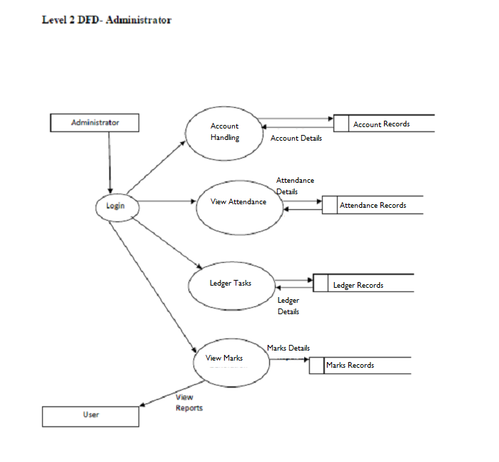

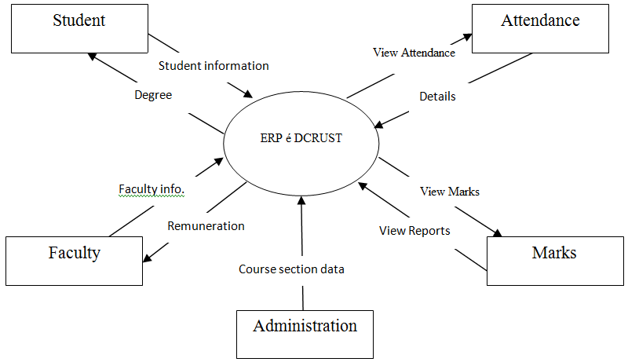

**4.7 DATABASE DESIGN**

A database is an organized mechanism that has the capability of storing information through which a user can retrieve stored information in an effective and efficient manner. The data is the purpose of any database and must be protected.

The database design is a two level process. In the first step, user requirements are gathered together and a database is designed which will meet these requirements as clearly as possible. This step is called Information Level Design and it is taken independent of any individual DBMS.

In the second step, this Information level design is transferred into a design for the specific DBMS that will be used to implement the system in question. This step is called Physical Level Design, concerned with the characteristics of the specific DBMS that will be used. A database design runs parallel with the system design.

The organization of the data in the database is aimed to achieve the following two major objectives.

* Data Integrity
* Data independence

Normalization is the process of decomposing the attributes in an application, which results in a set of tables with very simple structure. The purpose of normalization is to make tables as simple as possible.

Normalization is carried out in this system for the following reasons.

* To structure the data so that there is no repetition of data , this helps in

saving.

* To permit simple retrieval of data in response to query and report request.
* To simplify the maintenance of the data through updates, insertions,
* Deletions.
* To reduce the need to restructure or reorganize data which new application
* Requirements arise.

**4.7.1 RELATIONAL DATABASE MANAGEMENT SYSTEM (RDBMS):**

A relational model represents the database as a collection of relations. Each relation resembles a table of values or file of records. In formal relational model terminology, a row is called a tuple, a column header is called an attribute and the table is called a relation. A relational database consists of a collection of tables, each of which is assigned a unique name. A row in a tale represents a set of related values.

**RELATIONS, DOMAINS & ATTRIBUTES:**

A table is a relation. The rows in a table are called tuples. A tuple is an ordered set of n elements. Columns are referred to as attributes. Relationships have been set between every table in the database. This ensures both Referential and Entity Relationship Integrity. A domain D is a set of atomic values. A common method of specifying a domain is to specify a data type from which the data values forming the domain are drawn. It is also useful to specify a name for the domain to help in interpreting its values. Every value in a relation is atomic, that is not decomposable.

## RELATIONSHIPS:

* Table relationships are established using Key. The two main keys of prime importance are Primary Key & Foreign Key. Entity Integrity and Referential Integrity Relationships can be established with these keys.
* Entity Integrity enforces that no Primary Key can have null values.
* Referential Integrity enforces that no Primary Key can have null values.
* Referential Integrity for each distinct Foreign Key value, there must exist a matching Primary Key value in the same domain. Other key are Super Key and Candidate Keys.
* Relationships have been set between every table in the database. This ensures both Referential and Entity Relationship Integrity.

**4.8 ER DIAGRAMS**

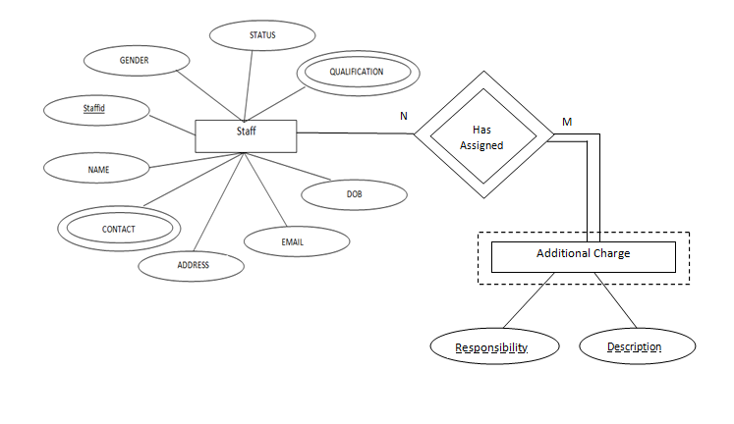

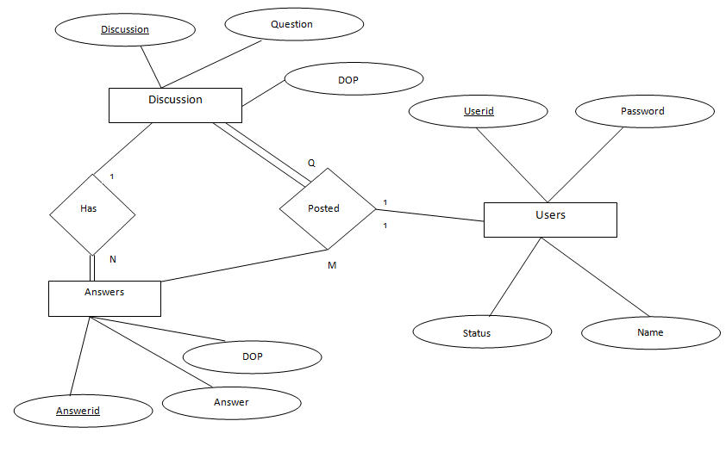

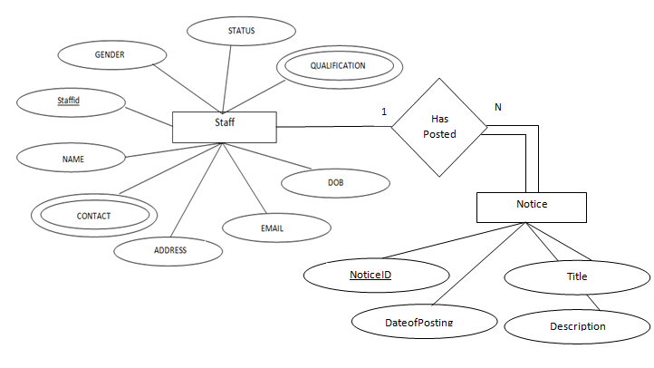

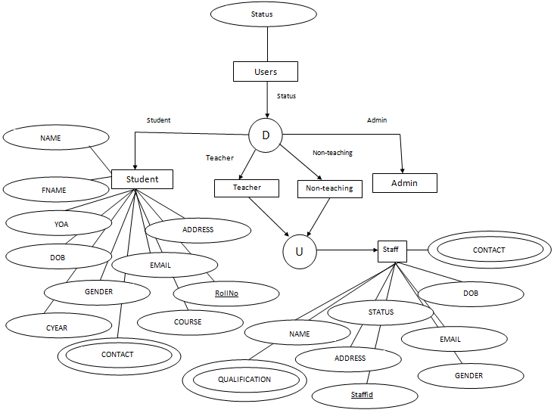

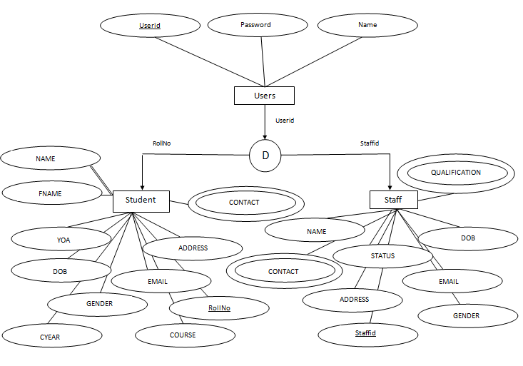

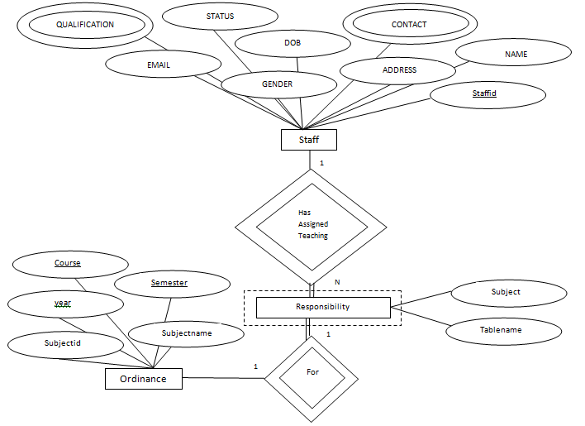

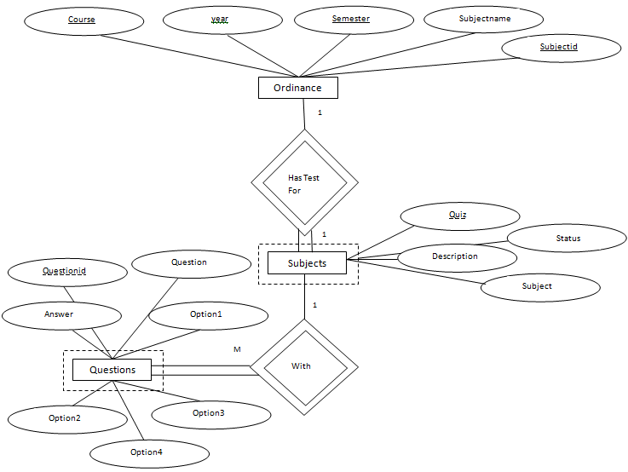

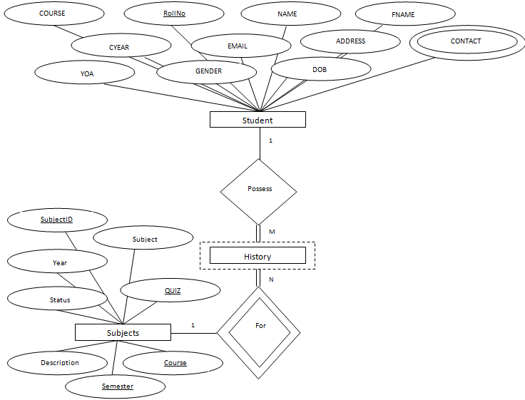

**4.9 Table Structures**

USERS

|  |  |  |
| --- | --- | --- |
| **NAME** | **NULL?** | **TYPE** |
| USERID | NOT NULL | VARCHAR2(50) |
| PASSWORD |  | VARCHAR2(50) |
| STATUS |  | VARCHAR2(10) |
| NAME |  | VARCHAR2(50) |

STUDENT

|  |  |  |
| --- | --- | --- |
| **NAME** | **NULL?** | **TYPE** |
| ROLLNO | NOT NULL | VARCHAR2(50) |
| NAME |  | VARCHAR2(50) |
| FNAME |  | VARCHAR2(50) |
| CONTACT |  | INT |
| ADDRESS |  | VARCHAR2(200) |
| EMAIL |  | VARCHAR2(50) |
| DOB |  | DATE |
| YOA |  | INT |
| CYEAR |  | INT |
| GENDER |  | VARCHAR2(20) |
| COURSE |  | VARCHAR2(20) |

|  |  |  |
| --- | --- | --- |
| **NAME** | **NULL?** | **TYPE** |
| STAFFID | NOT NULL | VARCHAR2(50) |
| NAME |  | VARCHAR2(50) |
| CONTACT |  | INT |
| ADDRESS |  | VARCHAR2(200) |
| EMAIL |  | VARCHAR2(50) |
| DOB |  | DATE |
| QUALIFICATION |  | VARCHAR2(200) |
| STATUS |  | VARCHAR2(20) |
| GENDER |  | VARCHAR2(10) |

STAFF

HISTORY

|  |  |  |
| --- | --- | --- |
| **NAME** | **NULL?** | **TYPE** |
| USERID | NOT NULL | VARCHAR2(20) |
| SUBJECTID | NOT NULL | VARCHAR2(20) |
| QUIZ | NOT NULL | VARCHAR2(20) |
| YEAR | NOT NULL | INT |
| SCORE |  | VARCHAR2(20) |
| DATEOFTEST | NOT NULL | DATE |
| COURSE | NOT NULL | VARCHAR2(20) |
| SEMESTER | NOT NULL | VARCHAR2(20) |

RESPONSIBILITY

|  |  |  |
| --- | --- | --- |
| **NAME** | **NULL?** | **TYPE** |
| STAFFID | NOT NULL | VARCHAR2(20) |
| YEAR | NOT NULL | INT |
| COURSE | NOT NULL | VARCHAR2(20) |
| SUBJECTID | NOT NULL | VARCHAR2(20) |
| TABLENAME |  | VARCHAR2(50) |
| SUBJECT |  | VARCHAR2(50) |
| SEMESTER | NOT NULL | VARCHAR2(50) |

DISCUSSION

|  |  |  |
| --- | --- | --- |
| **NAME** | **NULL?** | **TYPE** |
| DICUSSIONID | NOT NULL | NUMBER(22) |
| USERID |  | VARCHAR2(50) |
| QUESTION |  | VARCHAR2(500) |
| DOP |  | DATE |

ANSWERS

|  |  |  |
| --- | --- | --- |
| **NAME** | **NULL?** | **TYPE** |
| DISCUSSIONID |  | NUMBER(22) |
| ANSWERID | NOT NULL | NUMBER(22) |
| USERID |  | VARCHAR(50) |
| ANSWER |  | VARCHAR2(100) |
| DOP |  | DATE |

NOTICE

|  |  |  |
| --- | --- | --- |
| **NAME** | **NULL?** | **TYPE** |
| NOTICEID | NOT NULL | NUMBER(22) |
| USERID |  | VARCHAR2(50) |
| TITLE |  | VARCHAR2(50) |
| DESCRIPTION |  | VARCHAR2(2000) |
| DATEOFPOSTING |  | DATE |

ORDINANCE

|  |  |  |
| --- | --- | --- |
| **NAME** | **NULL?** | **TYPE** |
| COURSE | NOT NULL | VARCHAR2(20) |
| YEAR | NOT NULL | INT |
| SEMESTER | NOT NULL | VARCHAR2(20) |
| SUBJECTID | NOT NULL | VARCHAR2(20) |
| SUBJECTNAME |  | VARCHAR2(1000) |

ADDITIONAL CHARGE

|  |  |  |
| --- | --- | --- |
| **NAME** | **NULL?** | **TYPE** |
| STAFFID | NOT NULL | VARCHAR2(50) |
| RESPONSIBILITY | NOT NULL | VARCHAR2(50) |
| DESCRIPTION | NOT NULL | VARCHAR2(200) |

LEDGER

|  |  |  |
| --- | --- | --- |
| **NAME** | **NULL?** | **TYPE** |
| REFERREDBY | NOT NULL | VARCHAR2(20) |
| ISSUENO | NOT NULL | INT |
| DATEOFISSUE |  | DATE |
| NAME |  | VARCHAR2(30) |
| ADDRESS |  | VARCHAR2(50) |
| PLACE |  | VARCHAR2(50) |
| SUBJECT |  | VARCHAR2(100) |

**5.SOFTWARE ENVIRONMENT**

**JAVA**

Java is a small, simple, safe, object oriented, interpreted or dynamically optimized, byte coded, architectural, garbage collected, multithreaded programming language with a strongly typed exception-handling for writing distributed and dynamicaly extensible programs.

Java is an object oriented programming language. Java is a high-level, third generation language like C, FORTRAN, Small talk, Pearl and many others. You can use

java to write computer applications that crunch numbers, process words, play games, store data or do any of the thousands of other things computer software can do.

Special programs called applets that can be downloaded from the internet and played safely within a web browser. Java a supports this application and the follow features make it one of the best programming languages.

* It is simple and object oriented
* It helps to create user friendly interfaces.
* It is very dynamic.
* It supports multithreading.
* It is platform independent
* It is highly secure and robust.
* It supports internet programming

**Java** is a programming language originally developed by Sun Microsystems and released in 1995 as a core component of Sun's Java platform. The language derives much of its syntax from C and C++ but has a simpler object model and fewer low-level facilities. Java applications are typically compiled to byte code which can run on any Java virtual machine (JVM) regardless of computer architecture.

The original and reference implementation Java compilers, virtual machines, and class libraries were developed by Sun from 1995. As of May 2007, in compliance with the specifications of the Java Community Process, Sun made available most of their Java technologies as free software under the GNU General Public License. Others have also developed alternative implementations of these Sun technologies, such as the GNU Compiler for Java and GNU Class path.

The Java language was created by James Gosling in June 1991 for use in a set top box project. The language was initially called *Oak*, after an oak tree that stood outside Gosling's office - and also went by the name *Green* - and ended up later being renamed to *Java*, from a list of random words. Gosling's goals were to implement a virtual machine and a language that had a familiar C/C++ style of notation.

**Primary goals**

There were five primary goals in the creation of the Java language:

1. It should use the object-oriented programming methodology.
2. It should allow the same program to be executed on multiple operating systems.
3. It should contain built-in support for using computer networks.
4. It should be designed to execute code from remote sources securely.
5. It should be easy to use by selecting what were considered the good parts of other object-oriented languages.

The Java platform is the name for a bundle of related programs, or platform, from Sun which allow for developing and running programs written in the Java programming language. The platform is not specific to any one processor or operating system, but rather an execution engine (called a virtual machine) and a compiler with a set of standard libraries which are implemented for various hardware and operating systems so that Java programs can run identically on all of them.

The essential components in the platform are the Java language compiler, the libraries, and the runtime environment in which Java intermediate byte code "executes" according to the rules laid out in the virtual machine specification.

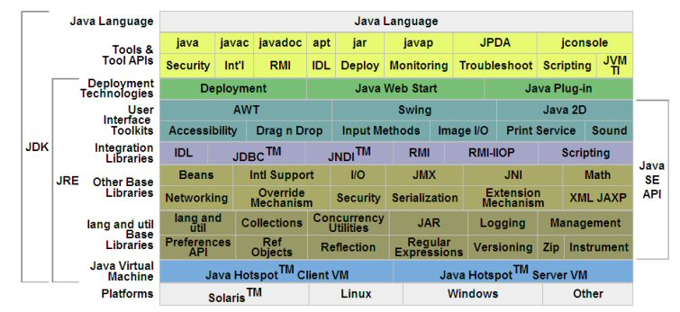

**JAVA VIRTUAL MACHINE**

The heart of the Java Platform is the concept of a "virtual machine" that executes Java byte code programs. This byte code is the same no matter what hardware or operating system the program is running under. There is a JIT compiler within the *Java Virtual Machine*, or JVM. The JIT compiler translates the Java byte code into native processor instructions at run-time and caches the native code in memory during execution.

The use of byte code as an intermediate language permits Java programs to run on any platform that has a virtual machine available. The use of a JIT compiler means that Java applications, after a short delay during loading and once they have "warmed up" by being all or mostly JIT-compiled, tend to run about as fast as native programs. Since JRE version 1.2, Sun's JVM implementation has included a just-in-time compiler instead of an interpreter.

Although Java programs are Platform Independent, the code of the Java Virtual Machine (JVM) that execute these programs are not. Every Operating System has its own JVM.

**J2EE COMPONENTS**

J2EE applications are made up of components. A *J2EE component* is a self-contained functional software unit that is assembled into a J2EE application with its related classes and files and that communicates with other components. The J2EE specification defines the following J2EE components:

* Application clients and applets are components that run on the client.
* Java Server and Java Server Pages (JSP) technology components are Web components that run on the server.
* Enterprise JavaBeans (EJB) components (enterprise beans) are business components that run on the server.

J2EE components are written in the Java programming language and are compiled in the same way as any program in the language. The difference between J2EE components and "standard" Java classes is that J2EE components are assembled into a J2EE application, verified to be well formed and in compliance with the J2EE specification, and deployed to production, where they are run and managed by the J2EE server.

**J2EE CLIENTS**

A J2EE client can be a Web client or an application client.

**WEB CLIENTS**

A Web client consists of two parts: dynamic Web pages containing various types of markup language (HTML, XML, and so on), which are generated by Web components running in the Web tier, and a Web browser, which renders the pages received from the server.

A Web client is sometimes called a *thin client*. Thin clients usually do not do things like query databases, execute complex business rules, or connect to legacy applications. When you use a thin client, heavyweight operations like these are off-loaded to enterprise beans executing on the J2EE server where they can leverage the security, speed, services, and reliability of J2EE server-side technologies.

**APPLICATION CLIENT**

A J2EE application client runs on a client machine and provides a way for users to handle tasks that require a richer user interface than can be provided by a markup language. It typically has a graphical user interface (GUI) created from Swing or Abstract Window Toolkit (AWT) APIs, but a command-line interface is certainly possible.

Application clients directly access enterprise beans running in the business tier. However, if application requirements warrant it, a J2EE application client can open an HTTP connection to establish communication with a servlet running in the Web tier.

**JAVABEANS COMPONENT ARCHITECTURE**

The server and client tiers might also include components based on the JavaBeans component architecture (JavaBeans component) to manage the data flow between an application client or applet and components running on the J2EE server or between server components and a database. JavaBeans components are not considered J2EE components by the J2EE specification.

**J2EE SERVER COMMUNICATION**

The client communicates with the business tier running on the J2EE server either directly or, as in the case of a client running in a browser, by going through JSP pages or servlets running in the Web tier.J2EE application uses a thin browser-based client or thick application client. In deciding which one to use, you should be aware of the trade-offs between keeping functionality on the client and close to the user (thick client) and off-loading as much functionality as possible to the server (thin client). The more functionality you off-load to the server, the easier it is to distribute, deploy, and manage the application; however, keeping more functionality on the client can make for a better perceived user experience.

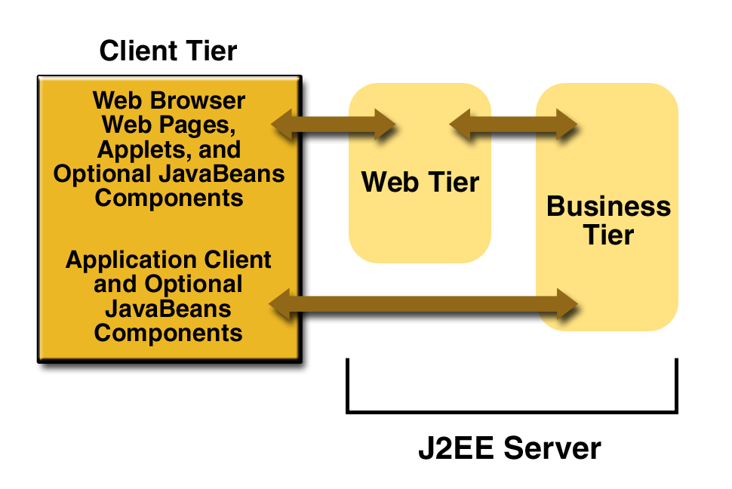

**Figure 1-2 Server Communications**

**WEB COMPONENT**

J2EE Web components can be either servlets or JSP pages. *Servlets* are Java programming language classes that dynamically process requests and construct responses. *JSP pages* are text-based documents that execute as servlets but allow a more natural approach to creating static content.Static HTML pages and applets are bundled with Web components during application assembly, but are not considered Web components by the J2EE specification. Server-side utility classes can also be bundled with Web components and, like HTML pages, are not considered Web components.Like the client tier and as shown in Figure 1-3, the Web tier might include a JavaBeans component to manage the user input and send that input to enterprise beans running in the business tier for processing.

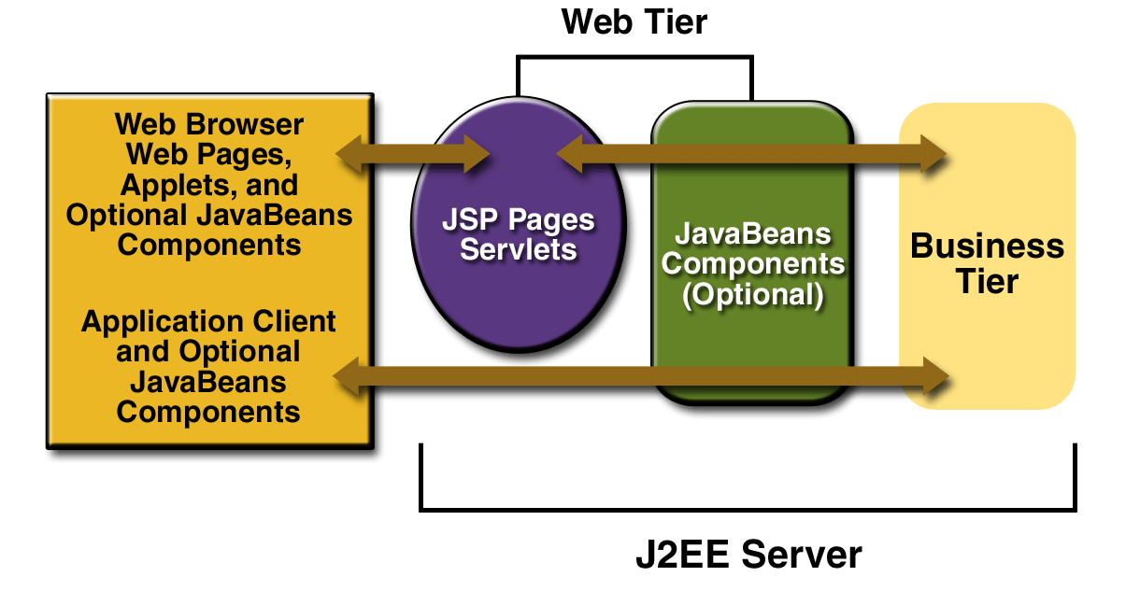

**Figure 1-3 Web Tier and J2EE Application**

**JAVA SERVER PAGE (JSP)**

Java Server Pages technology is the Java platform technology for building applications containing dynamic Web content such as HTML, DHTML and XML. The Java Server Pages technology enables the authoring of Web pages that create dynamic content easily but with maximum power and flexibility.

The Java Server Pages technology offers a number of advantages:

* *Write Once, Run Anywhere properties:*

The Java Server Pages technology is platform independent, both in its dynamic Web pages, its Web servers, and its underlying server components. You can author JSP pages on any platform, run them on any Web server or Web enabled application server, and access them from any Web browser. You can also build the server components on any platform and run them on any server.

* *High quality tool support*

The Write Once, Run Anywhere properties of JSP allows the user to choose *best-of-*

*breed* tools. Additionally, an explicit goal of the Java Server Pages design is to

enable the creation of high quality portable tools.

*  *Reuse of components and tag libraries*

The Java Server Pages technology emphasizes the use of reusable components such

as: JavaBeans components, Enterprise JavaBeans components and tag libraries.

These components can be used in interactive tools for component development and

page composition. This saves considerable development time while giving the cross-

platform power and flexibility of the Java programming language and other scripting

languages.

* *Separation of dynamic and static content*

The Java Server Pages technology enables the separation of static content from

dynamic content that is inserted into the static template. This greatly simplifies the

creation of content. This separation is supported by beans specifically designed for

the interaction with server-side objects.

* *Support for scripting and actions*

The Java Server Pages technology supports scripting elements as well as actions.

Actions permit the *encapsulation* of useful functionality in a convenient form that

can also be manipulated by tools; scripts provide a mechanism to *glue together* this

functionality in a per-page manner.

**JSP ARCHITECTURE**

JSPs are built on top of SUN’s servlet technology. JSPs are essential an HTML page with special JSP tags embedded. These JSP tags can contain Java code. The JSP file extension is .jsp rather than .htm or .html. The JSP engine parses the .jsp and creates a Java servlet source file. It then compiles the source file into a class file; this is done the first time and this why the JSP is probably slower the first time it is accessed. Any time after this the special compiled servlet is executed and is therefore returns faster.

**JAVA SCRIPT**

JavaScript is a programming language that allows scripting of events, objects, and actions to create Internet applications. A website development environment that will allow the

creation of Interactive Web Pages. The coding techniques capable of accepting a client's requests and processing these requests.

The web site development environment should also provide the facility for 'validating' user input. With JavaScript, forms are a consideration in nearly every page you design. Capturing user requests is traditionally done via a 'form'. So the web site needs to have facilities to create forms. Text fields and textareas can dynamically change in response to user responses.

**TOMCAT 5.0**

Tomcat is a servlet container and Java Server Pages implementation it may be used stand alone ,or in conjunction with several popular web servers .

* Apache version 1.3 or later
* MS Internet Information Server ,version 4.0 or later
* MS personel web server, version 4.0 or later
* NetScape enterprise server , version 3.0 or later

Tomcat is a security update release.This release closes a whole that potentially allowed access to resourse protected by a <security constraint > in web.xml.

Installing and Running Tomcat 5.0

Tomcat requires a Java Runtime Environment (JRE).Conformant to JRE 1.1 or later including any Java2 platform system.If one wishes to develop applications you will need a java compiler , such as the one included in a java development kit 1.1 or later environment including JDKs conformant with Java2.

**FEATURES OF OS**

      This project work is done on the windows 2000 professional, which is the operating system. An operating system is a set of software tools designed to make it easy for people or programmers to make optimum use of the computer. People who use computers have different levels of needs and interest. These peoples can be separated can be two groups, users and programmers. The user wants a convenient set of commands to manage files of

data or programs, copy and run application package while a programmer used as a set of tools that can be held together and debug programs.

      No matter where you are working, your computer will be easier to use and manage, because Microsoft Windows 2000 Professional is more compatible and more powerful than any workstation you’ve used before. The main features of Windows 2000 Professional operating system are

* Easier to use.
* Easier to manage
* More compatible
* More powerful

**Easier to use**

      With Windows 2000 Professional, you have faster access to information, and you arte able to accomplish tasks more quickly and easily.

 Windows 2000 Professional makes it easier to:

* Work with files.
* Find information.
* Personalize your computing environment.
* Work on the web.
* Work remotely

**Easier to manage**

      You and your network administrators can work more efficiently now, because many of the most common computer-management tasks are automated are streamlined with Windows 2000 Professional.

 With Windows 2000, your workstation will be easier to:

* Set up.
* Administrator
* Support.

**More Compatible**

      Windows 2000 Professional offers increased compatibility with different types of network and with a wide array of legacy hardware and software.

Windows 2000 also provides:

* Improved driver support.
* Increased support for new-generation hardware multimedia technologies.

**More Powerful**

             For all your computing needs, Windows 2000 Professional provides:

* Industrial-strength reliability
* The highest level of security
* Powerful performance

Windows 2000 also contains the following features:

**5.1 SOFTWARE AND HARDWARE SPECIFICATION**

**5.1.1 Hardware Specification**

Processor : Pentium III/AMD Athlone XP

RAM : 128 MB

Hard disk : 20 GB

FDD : 1.44MB

Monitor : 14 inch

Mouse : 3 Button scroll

CD Drive : 52 X

Keyboard : 108 keys

**5.1.2 Software Specification**

Operating System : Windows 2000/xp

Languages : java 2(EJB2.0, JDBC, JSP, Servlet, Java Mail)

Front End : HTML, JavaScript

Platform : J2EE

Web Servers : Web Logic8.1/Tomcat 7.0

Backend : My SQL

Browser Program : Internet explorer/Mozilla Fireworks

# 5.2 CODE DETAILS

The purpose of code is to facilitate the identification, retrieval of the items and information. A code is an oriented collection of symbols design to provide unique identification of an entry or attribute. Code is built with manually exclusive features. Codes in all cases specify object which are physical or on performance characteristics. They are used to give optimal distraction and other information. Codes are used for identifying, accessing, storing and matching records. The codes insure that only one value of the code with a single meaning is correctly applied to give entity or attribute as described in various ways. Code can also be design in a manner easily understood and applied by the user.

##### **5.2.1 CODING STANDARDS**

The standard used in the development of the system is Microsoft Programming standards. it includes naming conversions of variables, constants and objects, standardized formats or labelling and commenting code, spacing, formatting and indenting.

##### **5.2.2 NAMING CONVENTION**

Classes’ names and interface names will start with capital letter. The function names will start with small letters and the first letter of each word in the function name will be in capital letter.

##### **5.2.3 LABELS AND COMMENTS**

Sufficient labels and comments are included in the description of it for the benefits if the developer and other programmers who might examine it later.

##### User Interface

1. For all the entry screen frames are used which will show the type of the user who is currently logged in and the menus.
2. Standard actions are used for standard actions.
3. Same font is related properties are used for similar screens.

The method of implementation and the time scale to be adopted are found out initially. Next the system is tested properly and the users are trained in the new procedures.

**5.3 SAMPLES CODES**

**Login:**

<%@ page language="java" contentType="text/html; charset=ISO-8859-1"

pageEncoding="ISO-8859-1"%>

<%@taglib prefix="c" uri="http://java.sun.com/jsp/jstl/core"%>

<!DOCTYPE html>

<html lang="en">

<head>

<title>ERP-E'-DCRUST</title>

<meta charset="utf-8">

<link rel="stylesheet" href="css/reset.css" type="text/css"

media="screen">

<link rel="stylesheet" href="css/style.css" type="text/css"

media="screen">

<link rel="stylesheet" href="css/layout.css" type="text/css"

media="screen">

<script type="text/javascript" src="js/jquery-1.6.min.js"></script>

<script src="js/cufon-yui.js" type="text/javascript"></script>

<script src="js/cufon-replace.js" type="text/javascript"></script>

<script src="js/Open_Sans_400.font.js" type="text/javascript"></script>

<script src="js/Open_Sans_Light_300.font.js" type="text/javascript"></script>

<script src="js/Open_Sans_Semibold_600.font.js" type="text/javascript"></script>

<script src="js/FF-cash.js" type="text/javascript"></script>

</head>

<body id="page2">

<!-- header -->

<div class="bg">

<div class="main">

<header>

<div class="row-1">

<h1>

ERP-E'-DCRUST <strong class="slog">Making Learning A

Better Experience</strong>

</h1>

<img src="images/DCRUSTLOGO.jpg" height=100px align="right"

style="margin-right: 40px; margin-top: -7px" />

</div>

<div class="row-2">

<nav>

<ul class="menu">

<li><a href="HomePage.jsp">Home Page</a></li>

<li><a class="active" href="Login.jsp">Login</a></li>

<li><a href="NoticeBoard.jsp">Notice Board</a></li>

</ul>

</nav>

</div>

</header>

<!-- content -->

<section id="content" style="height: 400px;">

<div class="padding">

<div class="wrapper p4">

<div class="col-1">

<div class="indent">

<p style="color: red">

<c:out value="${requestScope['status_register']}" default=" " />

</p>

<h3 style="color: #05A6E0">COMPUTER SCIENCE DEPARTMENT</h3>

<br /> <font size="4" style="line-height: 30px;"><i><b>

ERP-E'-DCRUST integrates all the department's processes,

students and teachers by <br /> streamlining its operation

in an efficient manner.The solution enables quick decision<br>

making at the right time. This aims at helping students save

time and get in touch <br /> with the department in a better

way.<br />

</b> </i> </font>

</div>

</div>

<div class="col-4" style="margin-left: 80px">

<div class="block-news">

<h3 class="color-4 p2">Log In Here</h3>

<form action="Login2.jsp" method="post">

<table>

<tr>

<td><c:out value="${requestScope.status}" default=" " /></td>

</tr>

<tr>

<td class="t1">Username :<input type="text"

name="username">

</td>

</tr>

<tr>

<td class="t1">Password :<input type="password"

name="password">

</td>

</tr>

<tr>

<td class="t1">Login as :<select name='status'><option

value="-1">Select&nbsp&nbsp&nbsp&nbsp&nbsp&nbsp&nbsp&nbsp&nbsp&nbsp&nbsp&nbsp&nbsp&nbsp&nbsp&nbsp&nbsp&nbsp&nbsp&nbsp&nbsp&nbsp&nbsp&nbsp&nbsp&nbsp&nbsp</option>

<option value="Student">Student</option>

<option value="Teacher">Teacher</option>

<option value="Steno">Steno</option>

<option value="Admin">Admin</option>

</select>

</td>

</tr>

<tr>

<td><input type="submit" value="Login"> <input

type="reset" value="Cancel"></td>

</tr>

<tr>

<td><a class="imp" href="ForgotPassword.jsp">Forgot

Password?</a></td>

</tr>

</table>

</form>

</div>

</div>

</div>

</div>

</section>

<!-- footer -->

</div>

</div>

</body>

</html>

<%@ page language="java" contentType="text/html; charset=ISO-8859-1"

pageEncoding="ISO-8859-1"%>

<%@taglib prefix="c" uri="http://java.sun.com/jsp/jstl/core"%>

<%@ taglib prefix="sql" uri="http://java.sun.com/jsp/jstl/sql"%>

<!DOCTYPE html>

<html lang="en">

<head>

<title>ERP-E'-DCRUST</title>

<meta charset="utf-8">

<link rel="stylesheet" href="css/reset.css" type="text/css"

media="screen">

<link rel="stylesheet" href="css/style.css" type="text/css"

media="screen">

<link rel="stylesheet" href="css/layout.css" type="text/css"

media="screen">

<script type="text/javascript" src="js/jquery-1.6.min.js"></script>

<script src="js/cufon-yui.js" type="text/javascript"></script>

<script src="js/cufon-replace.js" type="text/javascript"></script>

<script src="js/Open_Sans_400.font.js" type="text/javascript"></script>

<script src="js/Open_Sans_Light_300.font.js" type="text/javascript"></script>

<script src="js/Open_Sans_Semibold_600.font.js" type="text/javascript"></script>

<script src="js/FF-cash.js" type="text/javascript"></script>

<!--[if lt IE 9]>

<script type="text/javascript" src="js/html5.js"></script>

<link rel="stylesheet" href="css/ie.css" type="text/css" media="screen">

<![endif]-->

</head>

<body id="page5">

<!-- header -->

<div class="bg">

<div class="main">

<div class="row-1">

<h1>

ERP-E'-DRCUST <strong class="slog">Making Learning a

Better Experience</strong>

</h1>

<img src="images/DCRUSTLOGO.jpg" height=100px align="right"

style="margin-right: 40px; margin-top: -7px" />

</div>

<div class="row-2">

<nav>

<ul class="menu">

<li><a href="HomePage.jsp">Home Page</a></li>

<li><a href="Login.jsp">Login</a></li>

<li><a class="active" href="NoticeBoard.jsp">Notice Board</a></li>

</ul>

</nav>

</div>

<section id="content" style="width: 1050px">

<div class="padding">

<div class="wrapper margin-bot">

<div class="col-3">

<div class="indent">

<h2 class="p0">Notice</h2>

<sql:setDataSource var="snapshot"

driver="oracle.jdbc.driver.OracleDriver"

url="jdbc:oracle:thin:@localhost:1521:oracle" user="erp"

password="erp" />

<sql:query var="result" dataSource="${snapshot}">

select * from (select * from notice order by noticeid desc) where rownum<3

</sql:query>

<form id="contact-form" action="Contact.jsp" method="post">

<div

style="border: 1px solid black; background-color: white; height: 250px"

align="center">

<marquee behavior="scroll" direction="up" scrollamount="3"

scrolldelay="5" onmouseover="this.stop()"

onmouseout="this.start()">

<ul

style="margin: 0px; padding: 0px; position: relative; list-style-type: none; z-index: 1; height: 279px; top: 0px;">

<c:forEach var="row" items="${result.rows}">

<li

style="overflow: hidden; float: none; width: 194px; height: 20px;"><a

href="ViewNotice.jsp?title=${row.noticeid}">${row.title}</a></li>

<br>

</c:forEach>

</ul>

</marquee>

</div>

</form>

</div>

</div>

<br /> <br /> <br /> <br /> <br /> <img

src="images/Notice1.jpg" height=250px align="right"

style="margin-right: 20px; margin-top: -250px" />

</div>

</div>

</div>

</div>

</section>

</body>

</html>

**Attendance View Page:**

<%@page import="java.text.SimpleDateFormat"%>

<%@page import="java.sql.*"%>

<%@page import="java.util.*"%>

<%@page import="java.util.Date"%>

<%@ page language="java" contentType="text/html; charset=ISO-8859-1"

pageEncoding="ISO-8859-1"%>

<%@ taglib prefix="sql" uri="http://java.sun.com/jsp/jstl/sql"%>

<%@ taglib prefix="c" uri="http://java.sun.com/jsp/jstl/core"%>

<!DOCTYPE html>

<html>

<title>ERP-E'-DCRUST</title>

<meta charset="utf-8">

<link rel="stylesheet" href="css/reset.css" type="text/css"

media="screen">

<link rel="stylesheet" href="css/style.css" type="text/css"

media="screen">

<link rel="stylesheet" href="css/layout.css" type="text/css"

media="screen">

<link rel="stylesheet" href="css/styletable.css" type="text/css"

media="screen">

<script type="text/javascript" src="js/jquery-1.6.min.js"></script>

<script src="js/cufon-yui.js" type="text/javascript"></script>

<script src="js/cufon-replace.js" type="text/javascript"></script>

<script src="js/Open_Sans_400.font.js" type="text/javascript"></script>

<script src="js/Open_Sans_Light_300.font.js" type="text/javascript"></script>

<script src="js/Open_Sans_Semibold_600.font.js" type="text/javascript"></script>

<script type="text/javascript" src="js/tms-0.3.js"></script>

<script type="text/javascript" src="js/tms_presets.js"></script>

<script type="text/javascript" src="js/jquery.easing.1.3.js"></script>

<script src="js/FF-cash.js" type="text/javascript"></script>

<!--[if lt IE 9]>

<script type="text/javascript" src="js/html5.js"></script>

<link rel="stylesheet" href="css/ie.css" type="text/css" media="screen">

<![endif]-->

</head>

<body id="page1">

<!-- header -->

<div class="bg">

<div class="main">

<header>

<div class="row-1">

<h1>

ERP-E'-DRCUST <strong class="slog">Making Learning a

Better Experience</strong>

</h1>

<img src="images/DCRUSTLOGO.jpg" height=100px align="right"

style="margin-right: 40px; margin-top: -7px" />

</div>

<div class="row-2">

<nav>

<ul class="menu">

<%

if (session.getAttribute("status").toString().equals("Steno")) {

%>

<li><a href="TeacherView.jsp">Home Page</a></li>

<li><a class="active" href="TeacherAcademics.jsp">Academics</a></li>

<li><a href="NoticeBoardView.jsp">Notice Board</a></li>

<li><a href="DiscussionForumView.jsp">Discussion Forum</a></li>

<li><a href="ChangePassword.jsp">Account Settings</a></li>

<%

} else {

%>

<li><a href="Admin.jsp">Home Page</a></li>

<li><a href="AccountHandling.jsp">Account Handling</a></li>

<li><a class="active" href="DepartmentalTasksAdmin.jsp">Departmental

Tasks</a></li>

<li><a href="DiscussionForumView.jsp">Discussion Forum</a></li>

<li><a href="NoticeBoardView.jsp">Notice Board</a></li>

<%

}

%>

</ul>

</nav>

</div>

<div class="contentadmin" style="background: white;">

<br> <br>

<div>

<div class="padding" align="center">

<table>

<%

Connection conn = null;

int colm = 0;

String tname = "";

try {

Class.forName("oracle.jdbc.driver.OracleDriver");

String url, user, password;

url = user = password = null;

url = new String("jdbc:oracle:thin:@localhost:1521:oracle");

user = new String("erp");

password = new String("erp");

conn = DriverManager.getConnection(url, user, password);

PreparedStatement ps1 = conn

.prepareStatement("select tablename from responsibility where course=? and year=? and subjectid=?");

ps1.setString(1, request.getParameter("course").toString());

ps1.setString(2, request.getParameter("year").toString());

ps1.setString(3, request.getParameter("subjectid").toString());

ResultSet rs1 = ps1.executeQuery();

while (rs1.next())

tname = rs1.getString(1);

PreparedStatement ps = conn.prepareStatement("Select * from "

+ tname + " order by doa desc ");

ResultSet rs = ps.executeQuery();

ResultSetMetaData rsmd = rs.getMetaData();

out.println("<table><tr><td>");

out.println("<div style=\" margin-top:20px\"><table class=\"table2\"><thead><td style=\"height:65px;\"></td></thead>");

String style, chkinput, todayDate;

style = " style=\"width:100px\"";

chkinput = "<input type=\"checkbox\" name=\"";

for (int i = 2; i <= rsmd.getColumnCount(); i++) {

String str = rsmd.getColumnName(i);

if (str.charAt(0) == 'C')

str = str.substring(1);

out.println("<tr style=\"width=50px\"><td>" + str

+ "</td></tr>");

}

out.println("</table></div> </td> <td>");

out.println("<div style=\"overflow-x:scroll;overflow-y:visible; width:745px\">");

ArrayList<String> values = new ArrayList<String>();

ArrayList<String> dates = new ArrayList<String>();

int colCount = rsmd.getColumnCount() - 1;

colm = colCount;

while (rs.next()) {

String tdate, tvalue;

tdate = rs.getString(1);

tvalue = "";

for (int i = 2; i <= (colCount + 1); i++) {

tvalue += rs.getString(i);

}

values.add(tvalue);

dates.add(tdate);

}

Iterator<String> itrdate = dates.iterator();

Iterator<String> itrvalue = values.iterator();

out.println("<table class=\"table2\">");

out.println("<thead><tr>");

while (itrdate.hasNext()) {

out.println("<th>"

+ itrdate.next().toString().substring(0, 8)

+ "</th>");

}

out.println("<th>Percentage</th>");

out.println("</tr></thead>");

int present, maxp;

for (int i = 1; i <= colCount; i++) {

out.println("<tr>");

itrvalue = values.iterator();

present = 0;

maxp = 0;

while (itrvalue.hasNext()) {

String tmp = itrvalue.next().toString();

out.println("<td" + style + ">"

+ (char) tmp.charAt(i - 1) + "</td>");

if (tmp.charAt(i - 1) == ('P'))

present++;

maxp++;

}

float pout = (((float) present) / ((float) maxp)) * 100;

String fpout = String.format("%.1f", pout) + "%";

out.println("<td" + style + ">" + fpout + "</td>");

out.println("</tr>");

}

out.println("</table></div></td></tr></table>");

} catch (Exception e) {

System.out.println(e.toString());

}

%>

</table>

</div>

</div>

<br> <br>

</div>

</div>

</div>

</body>

</html>

**6. IMPLEMENTATION**

Implementation is the stage of the project where the theoretical design is turned into a working system. It can be considered to be the most crucial stage in achieving a successful new system gaining the users confidence that the new system will work and will be effective and accurate. It is primarily concerned with user training and documentation. Conversion usually takes place about the same time the user is being trained or later. Implementation simply means convening a new system design into operation, which is the process of converting a new revised system design into an operational one.

Implementation is the stage of the project where the theoretical design is tuned into a working system. At this stage the main work load, the greatest upheaval and the major impact on the existing system shifts to the user department. If the implementation is not carefully planned and controlled it can create chaos and confusion.

Implementation includes all those activities that take place to convert from the existing system to the new system. The new system may be a totally new, replacing an existing manual or automated system or it may be a modification to an existing system. Proper implementation is essential to provide a reliable system to meet organization requirements. The process of putting the developed system in actual use is called system implementation. This includes all those activities that take place to convert from the old system to the new system. The system can be implemented only after through testing is done and if it is found to be working according to the specifications. The system personnel check the feasibility of the system. The more complex the system being implemented, the more involved will be the system analysis and design effort required to implement the three main aspects: education and training, system testing and changeover. The implementation state involves the following tasks:

* Careful planning.
* Investigation of system and constraints.
* Design of methods to achieve the changeover.
* Training of the staff in the changeover phase.

**7.1 Implementation Procedures**

Implementation of software refers to the final installation of the package in its real environment, to the satisfaction of the intended uses and the operation of the system. In many organizations someone who will not be operating it, will commission the software development project. In the initial stage people doubt about the software but we have to ensure that the resistance does not build up, as one has to make sure that

* The active user must be aware of the benefits of using the new system.
* Their confidence in the software is built up.
* Proper guidance is imparted to the user so that he is comfortable in using the application.

Before going ahead and viewing the system, the user must know that for viewing the result, the server program should be running in the server. If the server object is not up running on the server, the actual process won’t take place.

**7.1.1 User Training**

User training is designed to prepare the user for testing and converting the system. To achieve the objective and benefits expected from computer based system, it is essential for the people who will be involved to be confident of their role in the new system. As system becomes more complex, the need for training is more important. By user training the user comes to know how to enter data, respond to error messages, interrogate the database and call up routine that will produce reports and perform other necessary functions.

**7.1.2 Training on the Application Software**

After providing the necessary basic training on computer awareness the user will have to be trained on the new application software. This will give the underlying philosophy of the use of the new system such as the screen flow, screen design type of help on the screen, type of errors while entering the data, the corresponding validation check at each entry and the ways to correct the date entered.

It should then cover information needed by the specific user/ group to use the system or part of the system while imparting the training of the program on the application. This training may be different across different user groups and across different levels of hierarchy.

**7.1.3 Operational Document**

Once the implementation plan is decided, it is essential that the user of the system is made familiar and comfortable with the environment. Education involves right atmosphere and motivating the user. A documentation providing the whole operations of the system is being developed in such a way that the user can work with it in well consistent way. The system is developed user friendly so that the user can work the system from the tips given in the application itself. Useful tip and guidance is given inside the application itself to help the user. Users have to be made aware that what can be achieved with the new system and how it increases the performance of the system. The user of the system should be given a general idea of the system before he uses the system.

**7.1.4 System Maintenance**

Maintenance is the enigma of system development. The maintenance phase of the software cycle is the time in which a software product performs useful work. After a system is successfully implemented, it should be maintained in a proper manner. System maintenance is an important aspect in the software development life cycle. The need for system maintenance is for it to make adaptable to the changes in the system environment. Software maintenance is of course, far more than "Finding Mistakes". Maintenance may be defined by describing four activities that are undertaken after a program is released for use.

**8. SCREEN SHOTS**

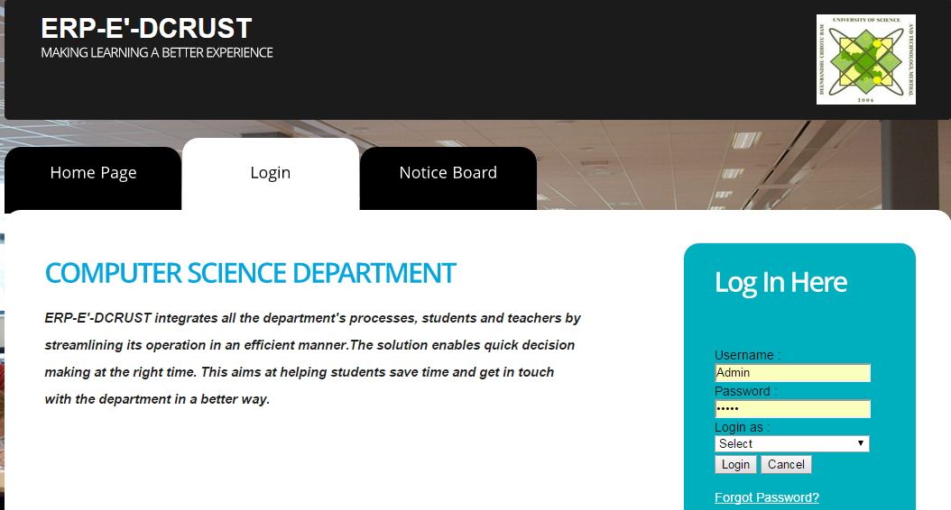

Login Page

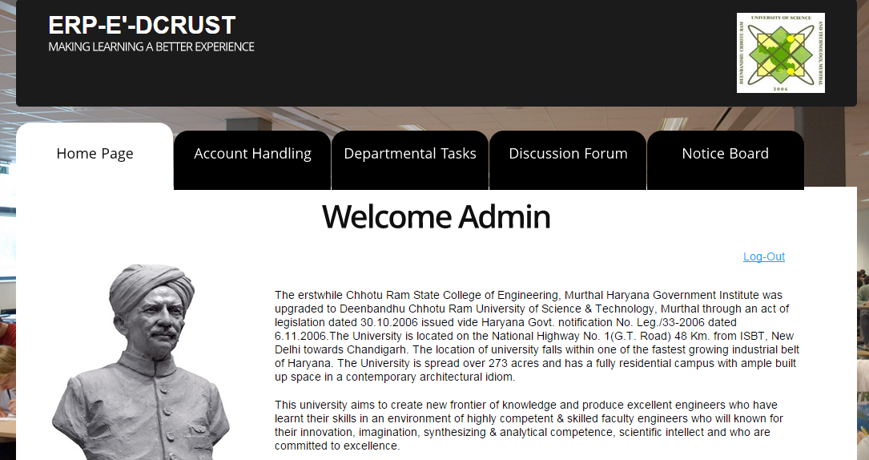

Admin Home

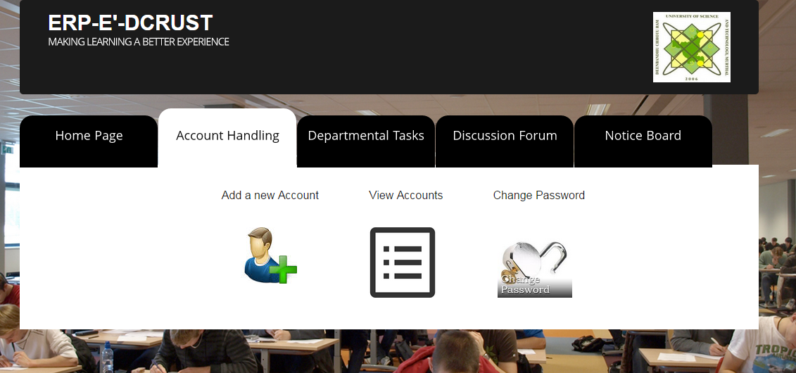

Account Handling page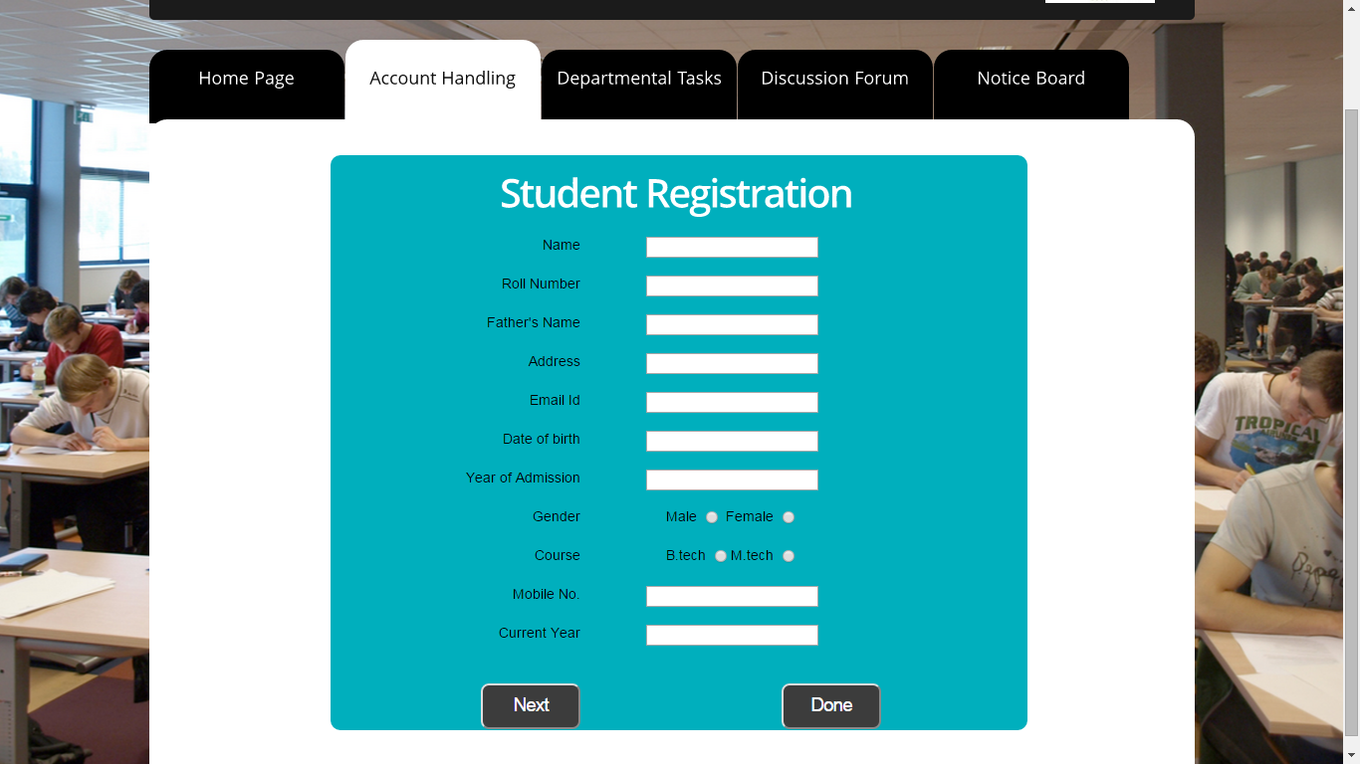Student Registration Page.

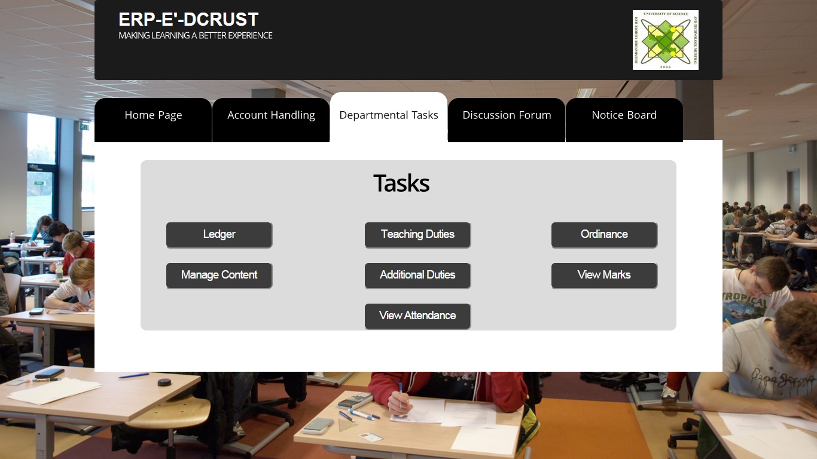

Departmental Tasks

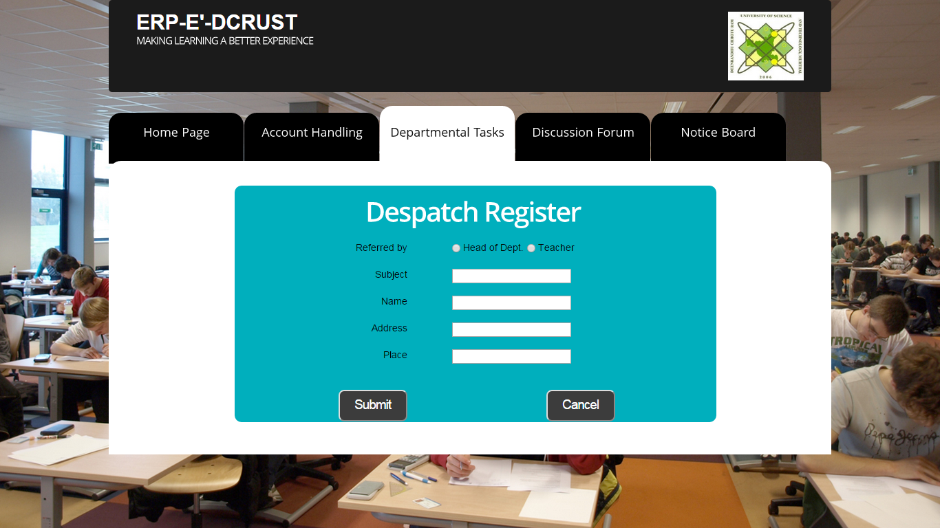

Add Ledger

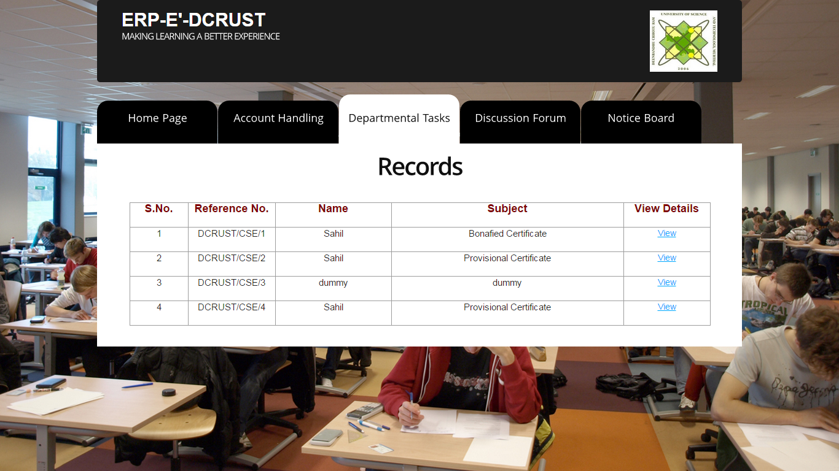

Ledger Records

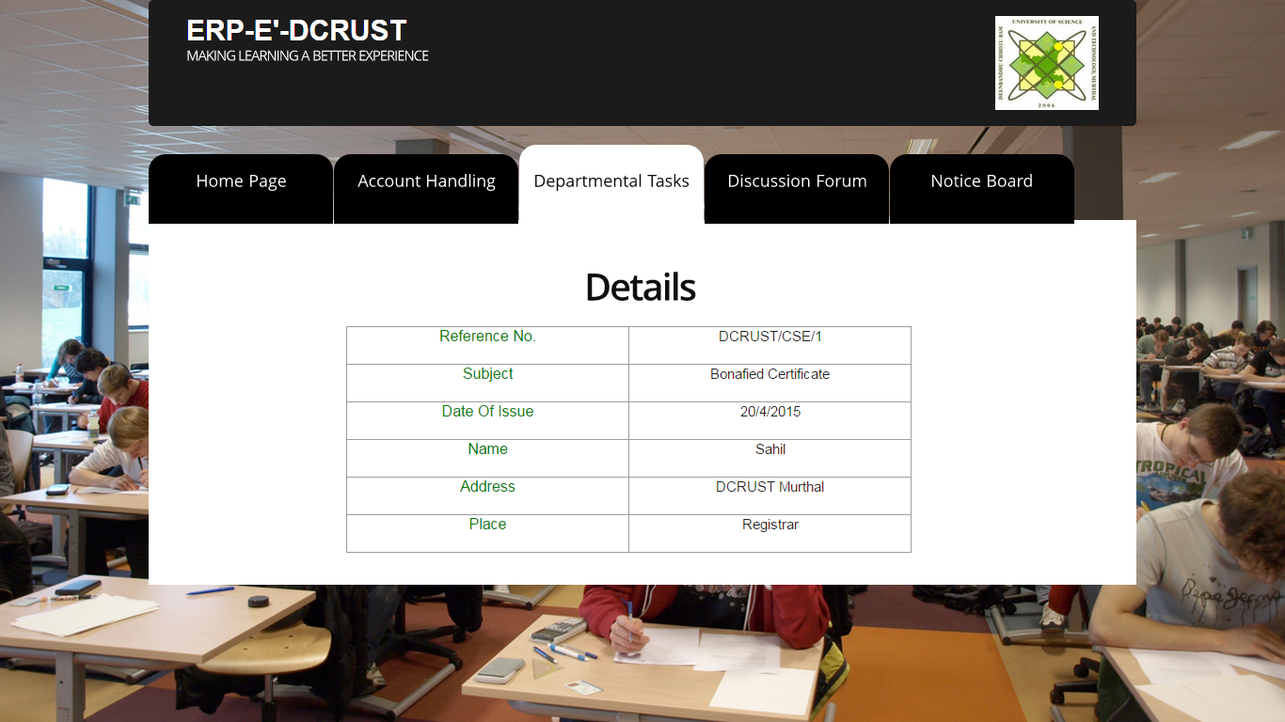

Ledger Record Details

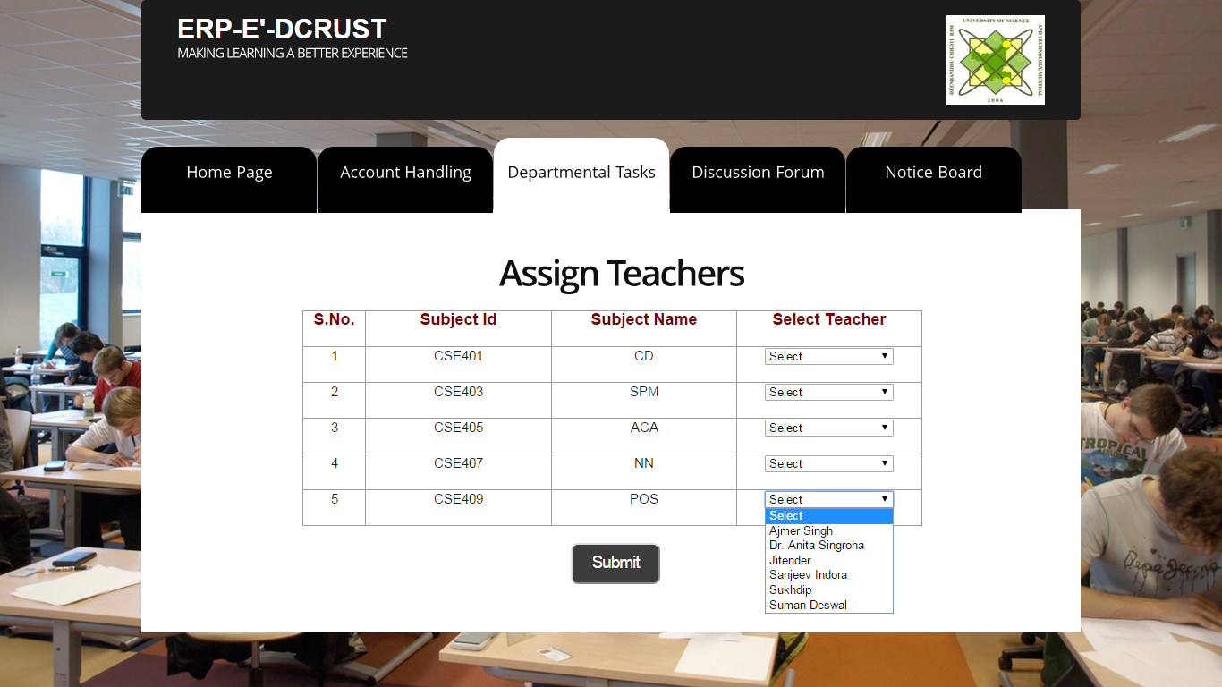

Assign Teacher Duty

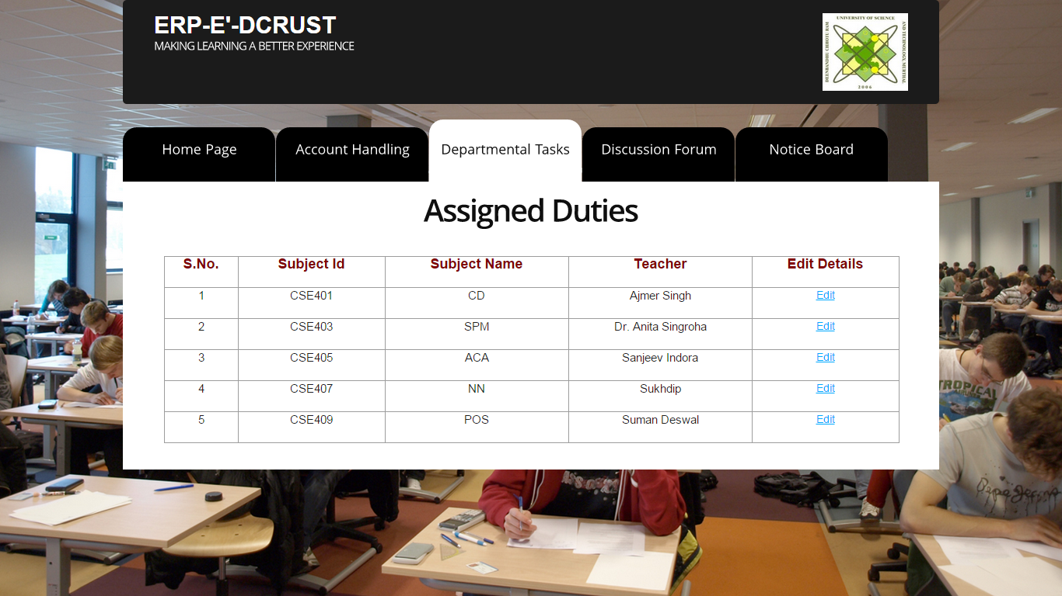

Teacher Duties View

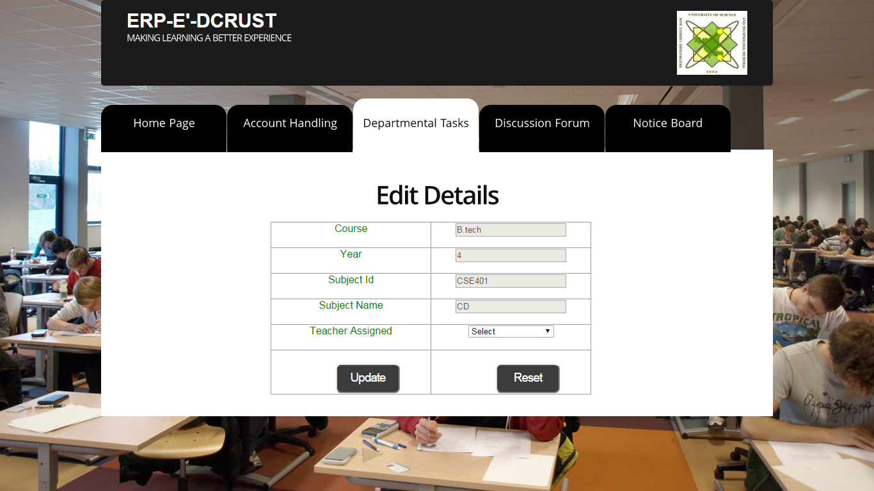

Assign Duties Edit

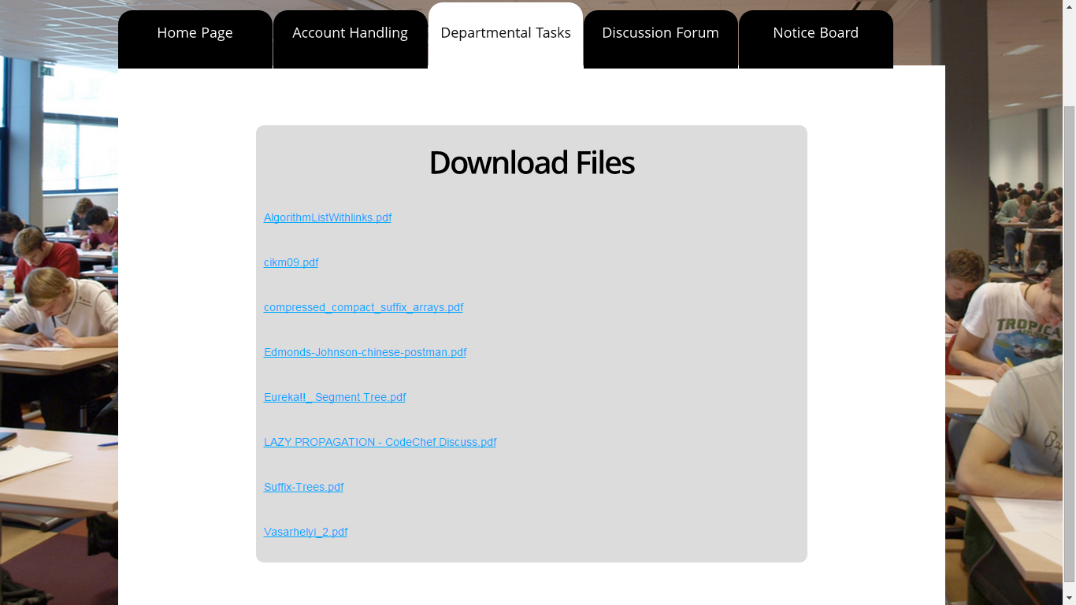

Download Files List

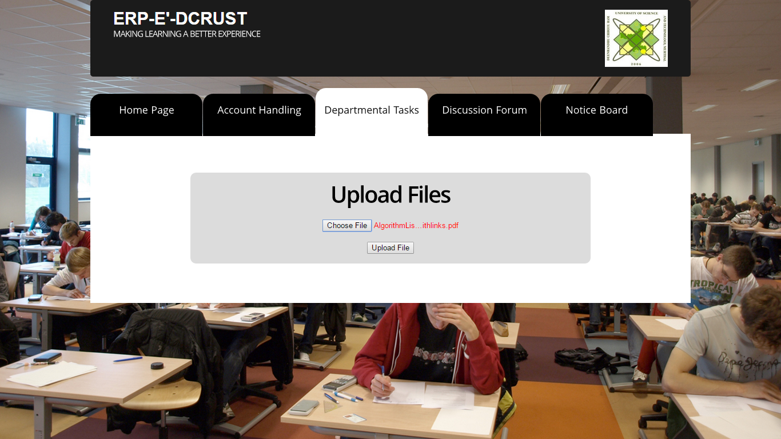

Upload Content Page

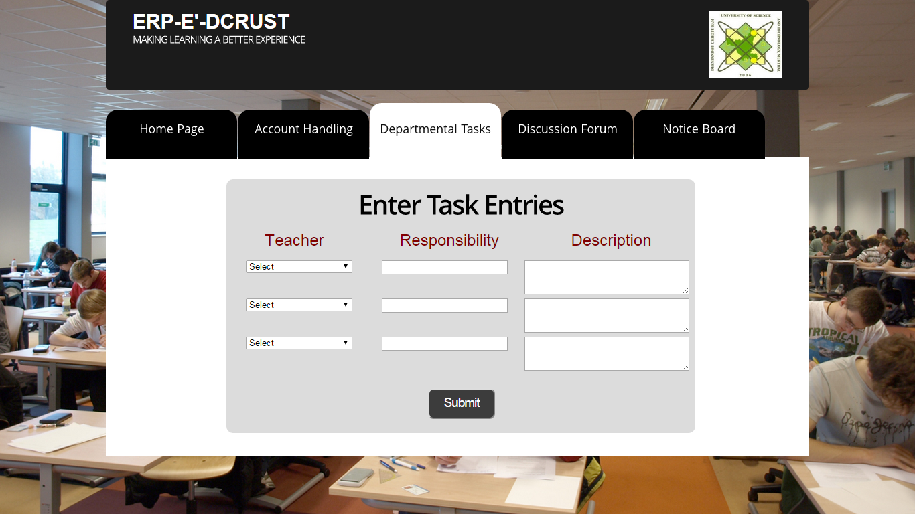

Add Additional Duties

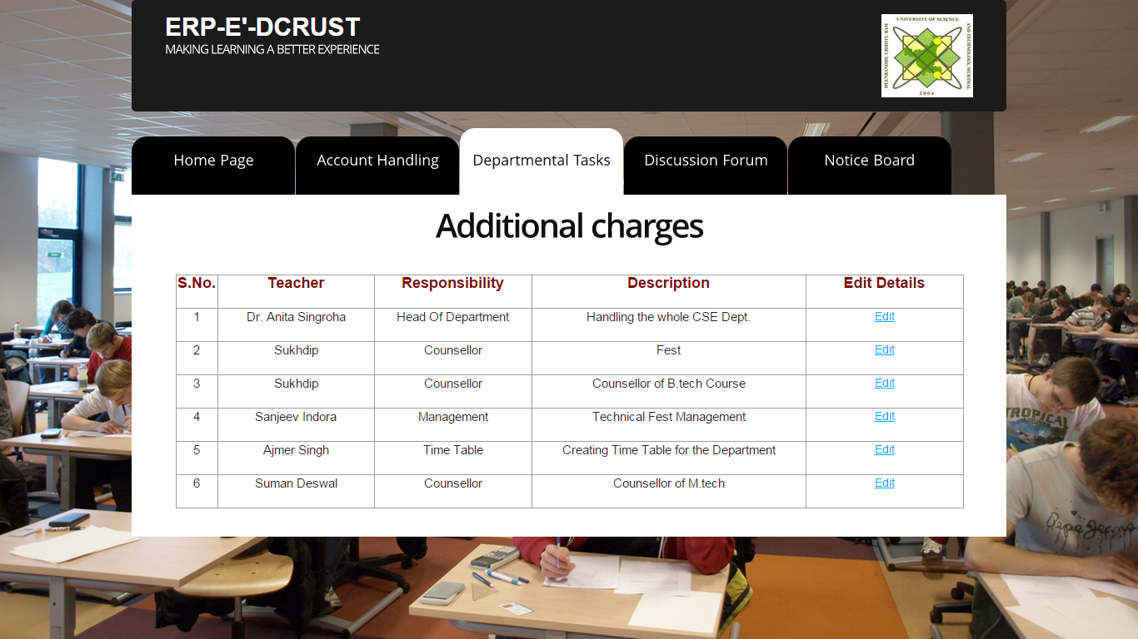

Additional Duty View

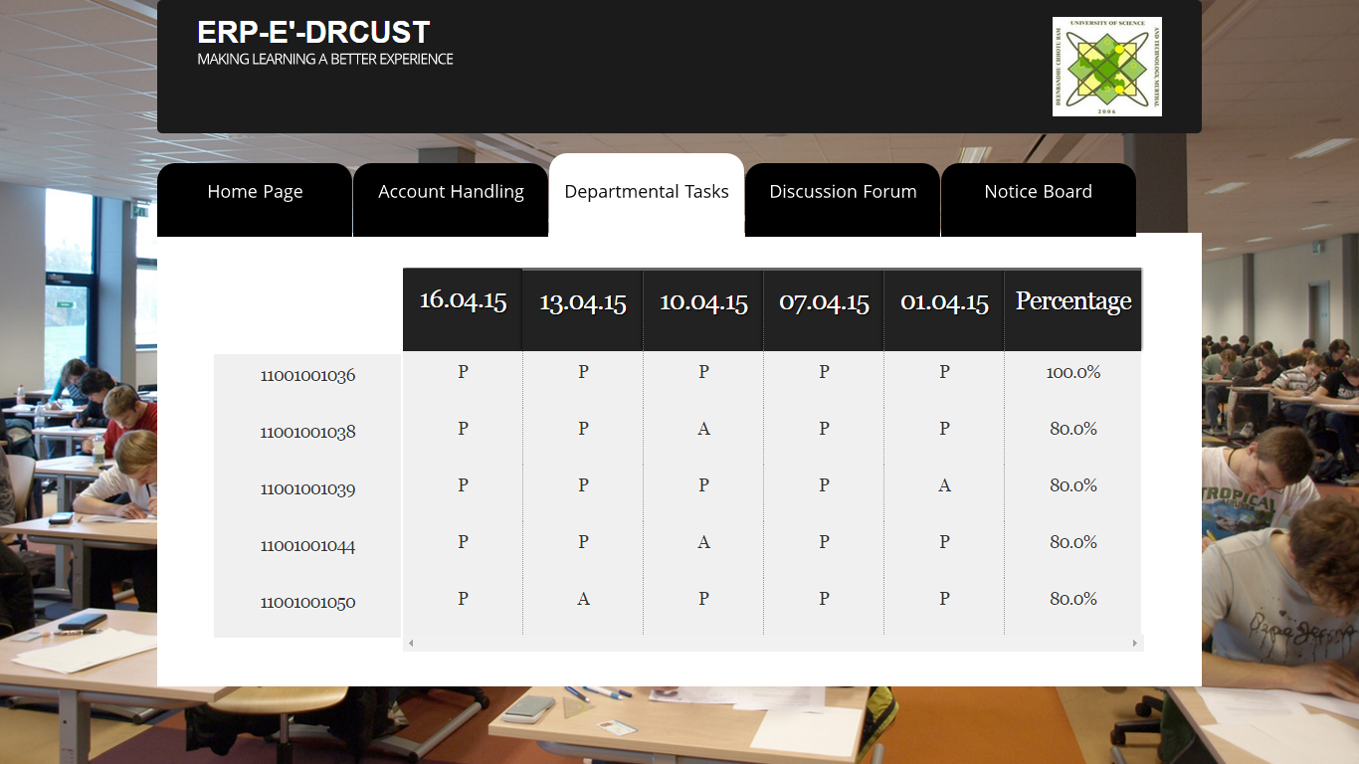

View Student Attendance

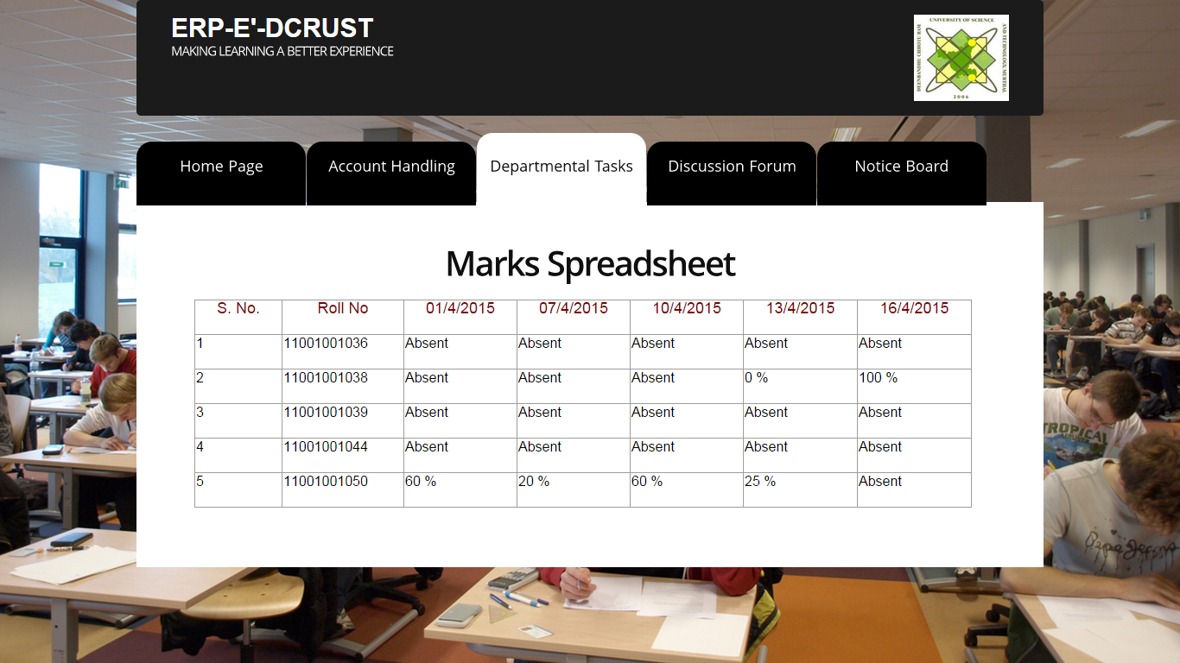

View Student Marks

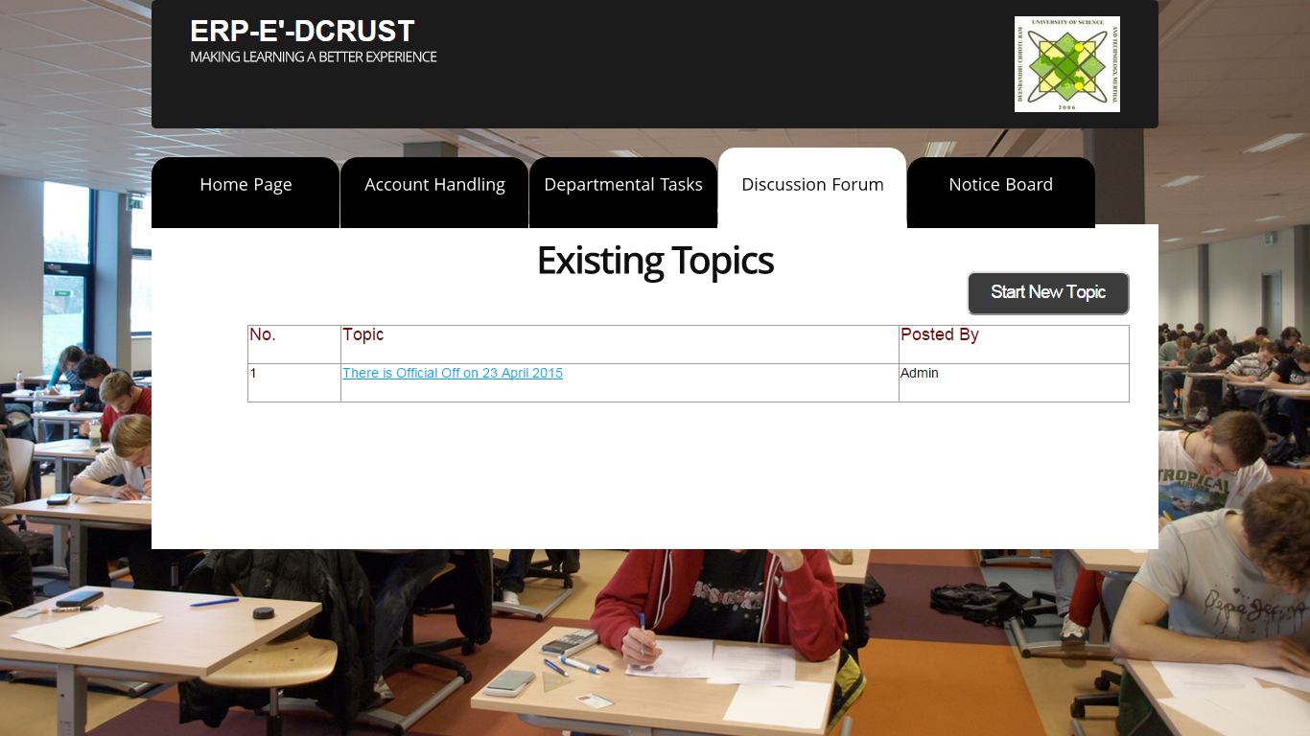

Discussion Forum

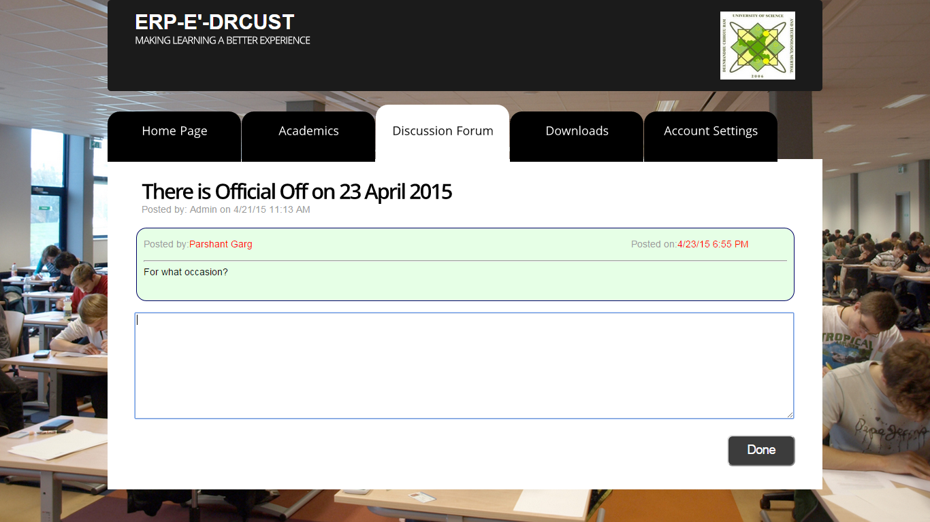

Ongoing Discussion in Discussion Forum

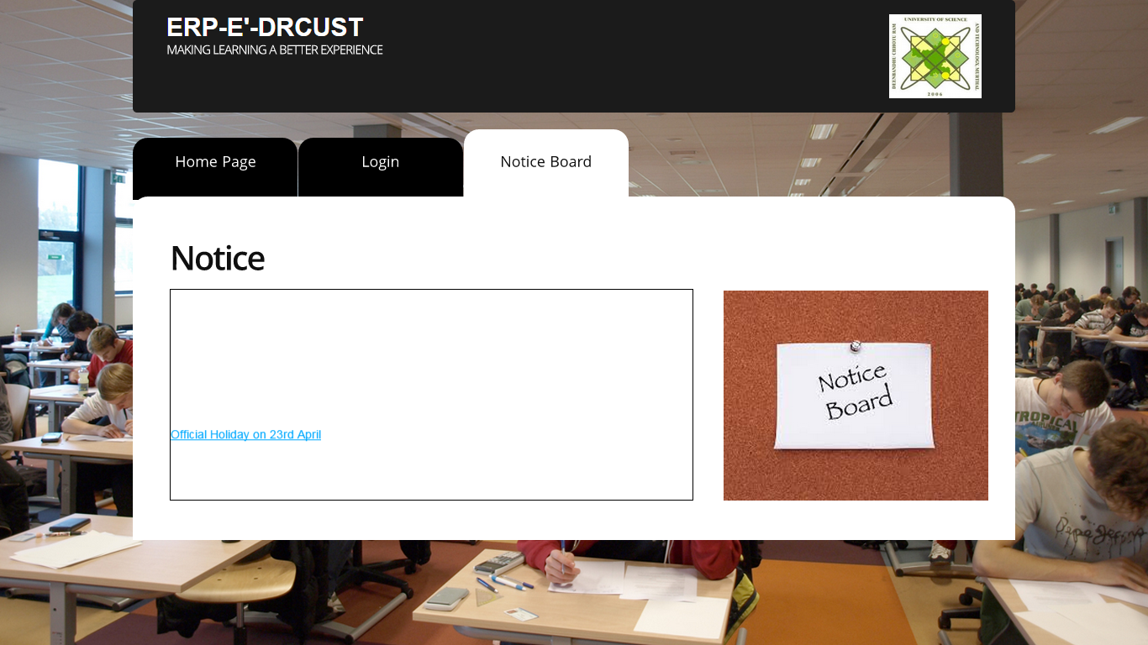

Notice Board

Teacher views

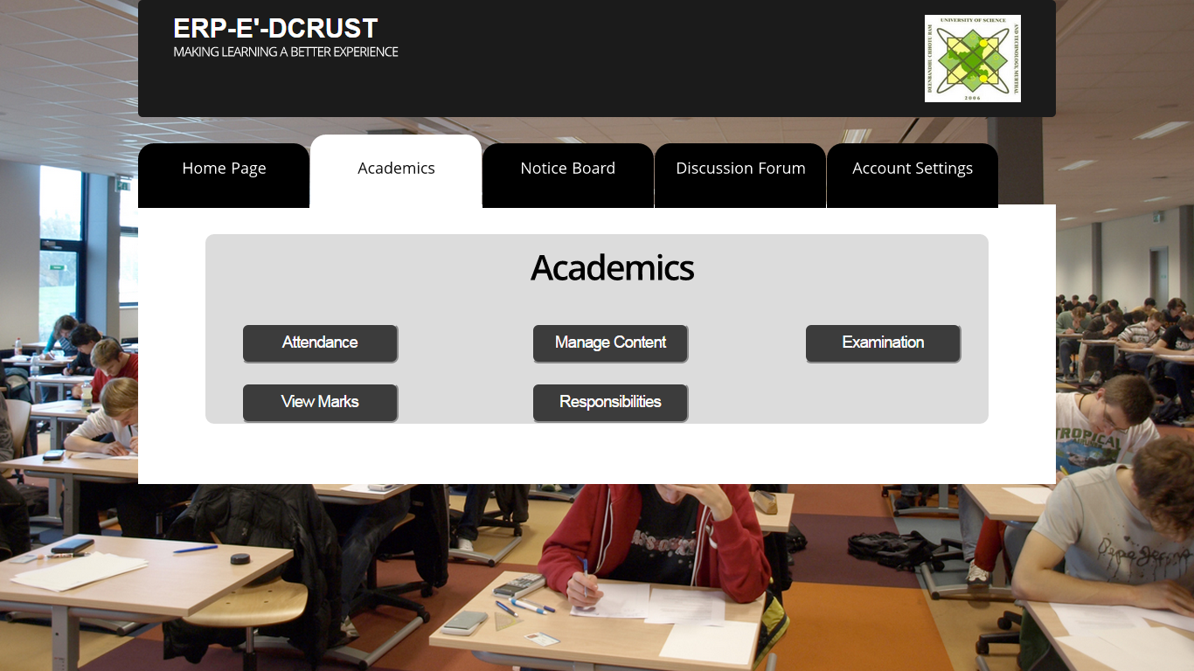

Academics Page in Teacher View

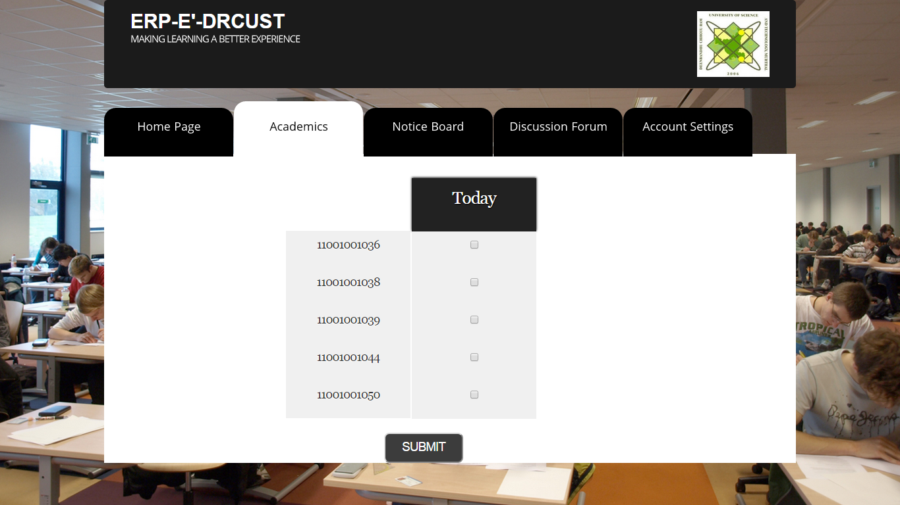

Attendance Marking in Teacher View

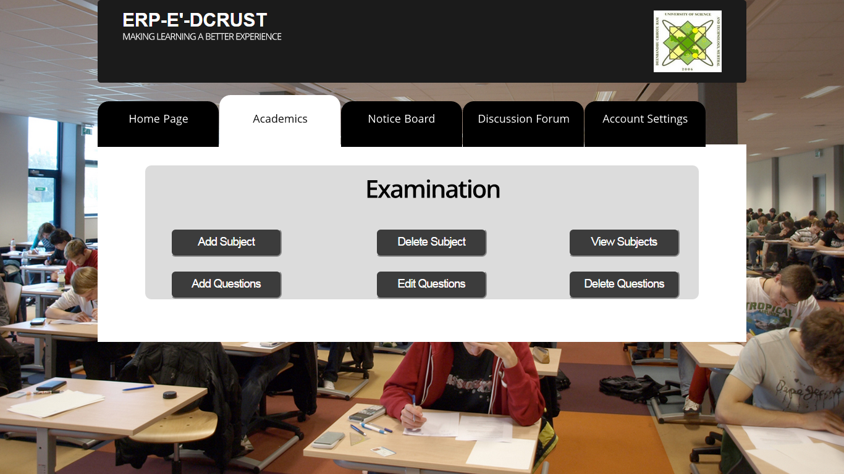

Examination Page in Teacher View



Student Marks as in Teacher View

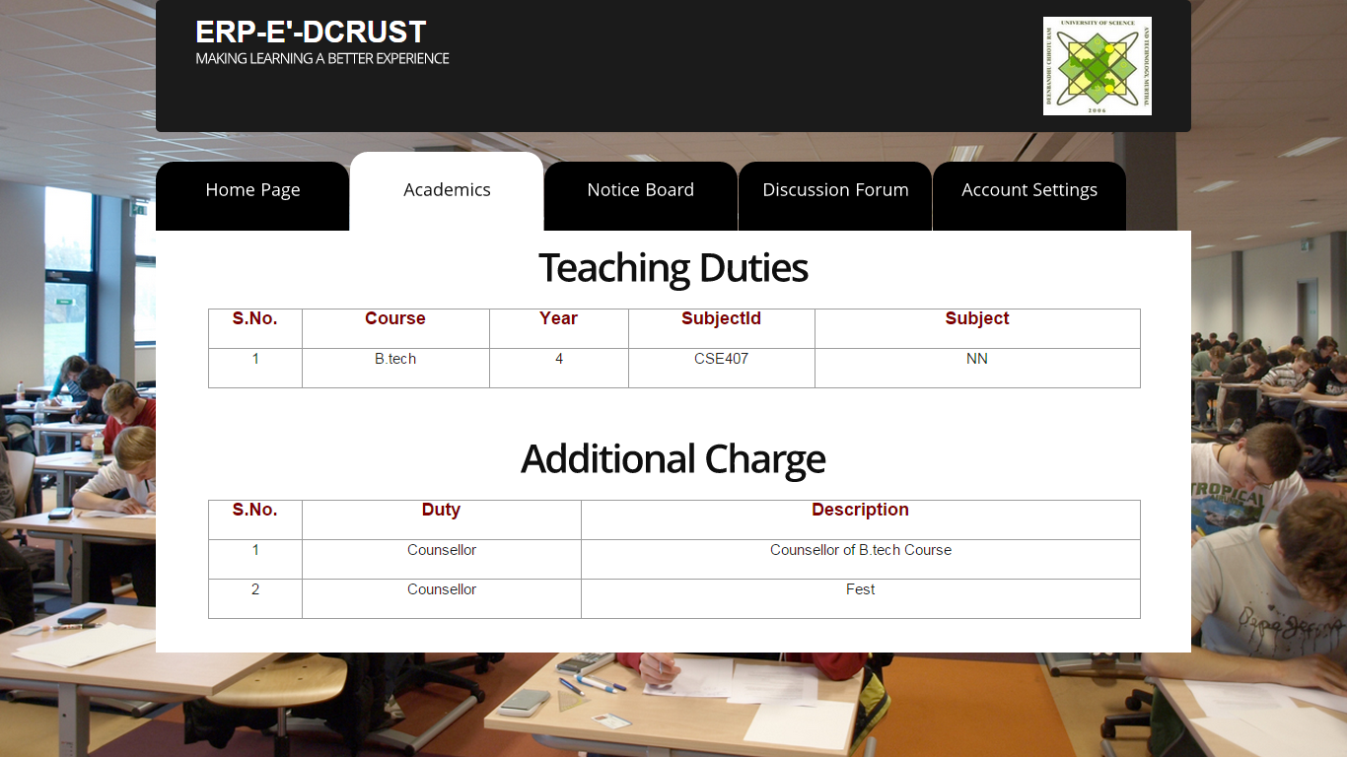

Teacher Responsibilities

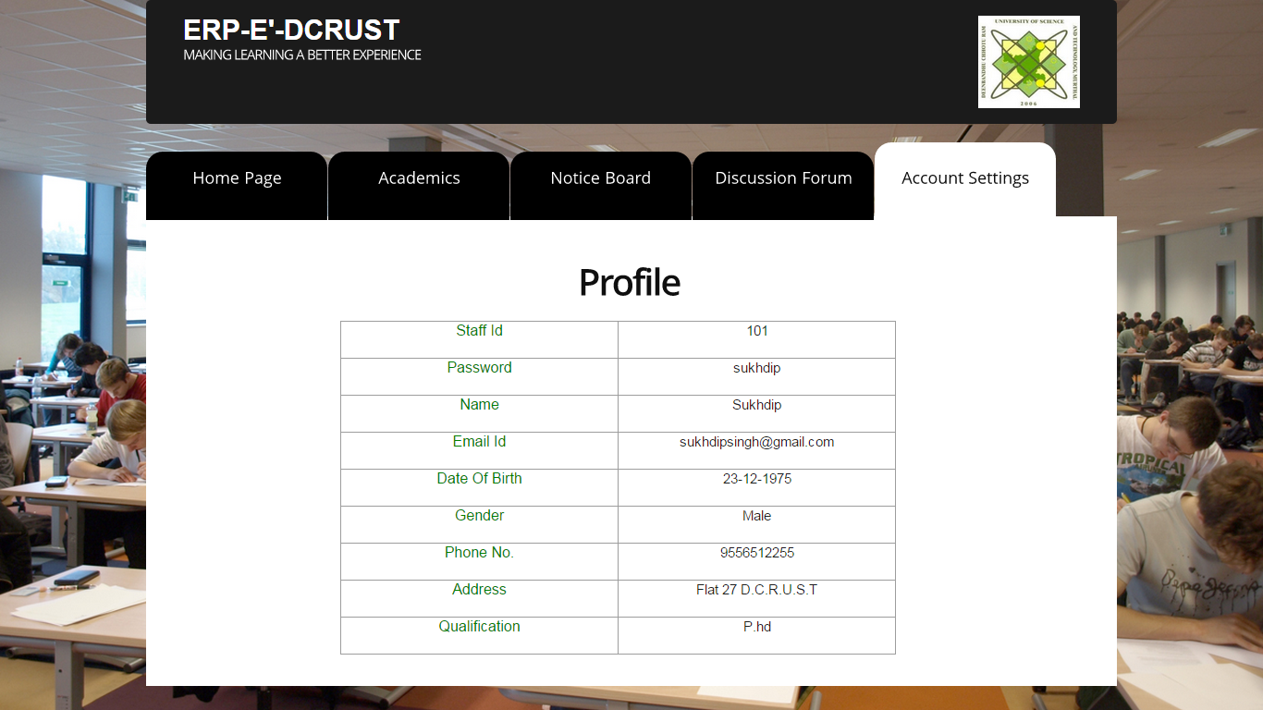

Teacher Profile

Student View

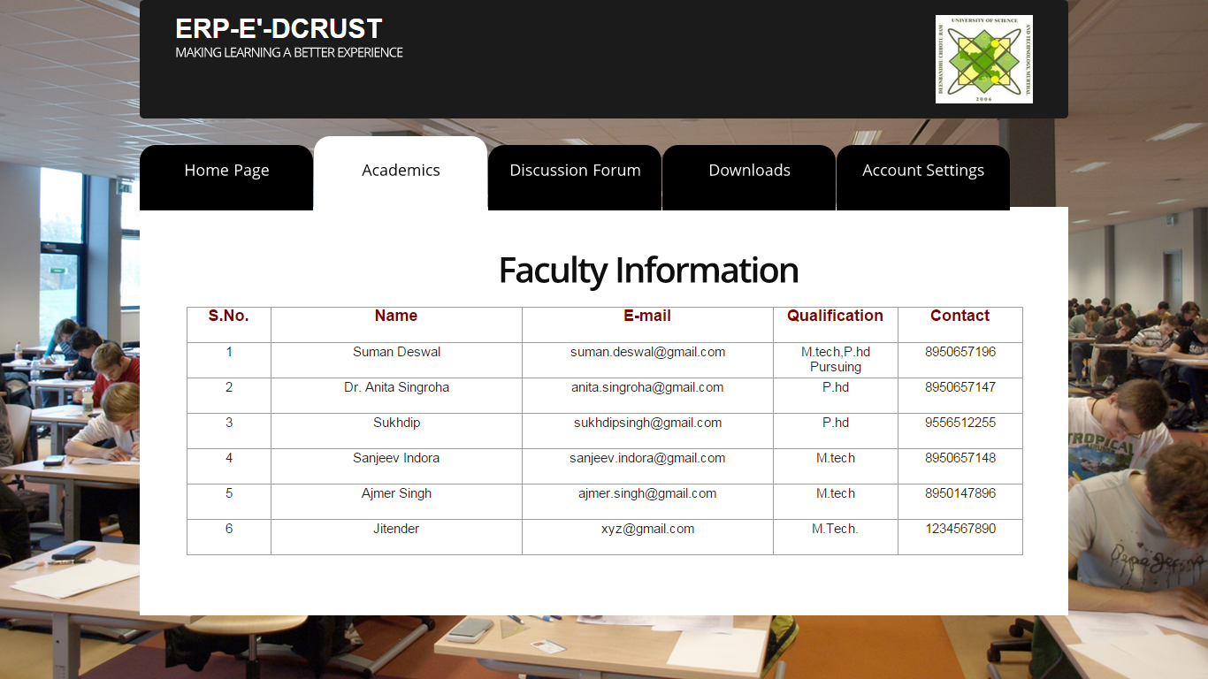

Faculty Information for Student View

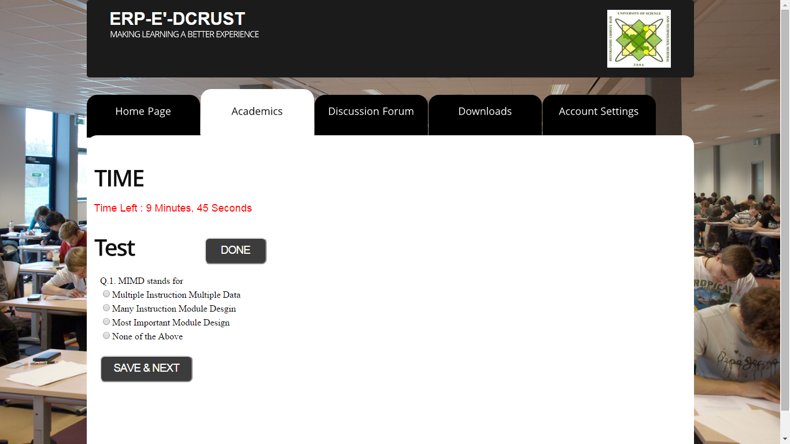

Take Test in Student View

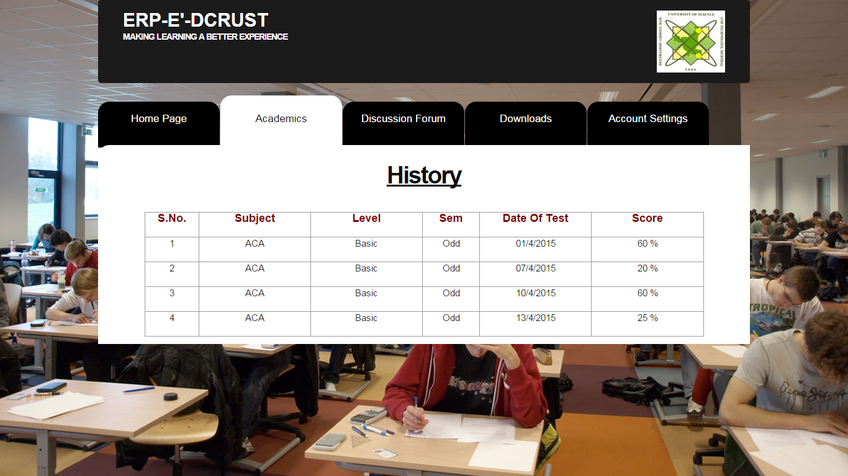

Student Marks History

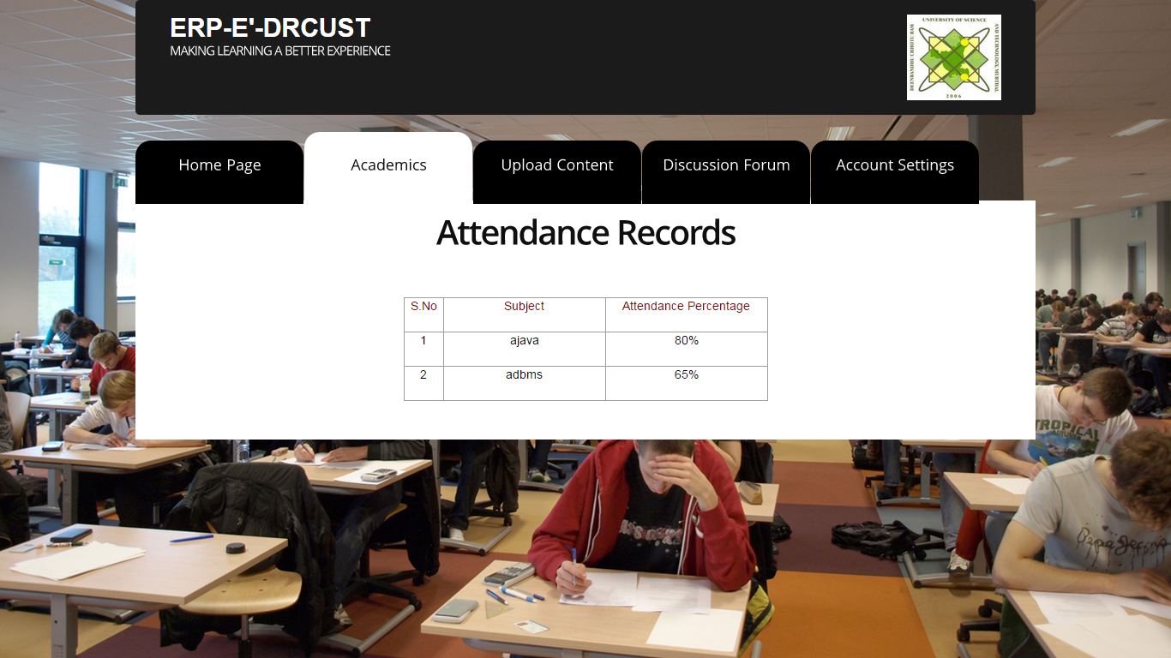

Attendance Record of Students

**9**. **CONCLUSION**

The project titled as “ERP é DCRUST” is a web based application. This software provides facility for viewing the CSE Department of DCRUST Murthal as a whole. That means it shows the main details about the department. The students can connect to the server. Each user first makes their login to server to show their availability. This software is developed with scalability in mind. Additional modules can be easily added when necessary. The software is developed with modular approach. All modules in the system have been tested with valid data and invalid data and everything work successfully. Thus the system has fulfilled all the objectives identified and is able to replace the existing system.

The project has been completed successfully with the maximum satisfaction of the organization. The constraints are met and overcome successfully. The system is designed as like it was decided in the design phase. The project gives good idea on developing a full-fledged application satisfying the user requirements.

The system is very flexible and versatile. This software has a user-friendly screen that enables the user to use without any inconvenience. Validation checks induced have greatly reduced errors. Provisions have been made to upgrade the software. The application has been tested with live data and has provided a successful result. Hence the software has proved to work efficiently.

**9. SCOPE OF FUTURE ENHANCEMENT**

In future we can able to add more modules in this project ERP é DCRUST. In the proposed system the user is provided with a choice of data screen, which are similar in formats to the source documents. Data entry errors can be minimized through validity checks. After the verification only the data are placed in the permanent database. The software can be developed further to include a lot of modules because the proposed system is developed on the view of future, for example we should develop the system as a database independent using JDBC so we can connect it to any other database. Now the proposed system is based on PC and intranet but in the future if we need to convert it into internet then we need to change the front end only because we are developing this on the basis of OOP technology and most of the business logic’s are bounded in the class files and module like reusable components.

**REFFERENCES**

* www.theserverside.com
* [www.java.sun.com](http://www.java.sun.com)
* [www.javatpoint.com](http://www.javatpoint.com)
* [www.stackoverflow.com](http://www.stackoverflow.com)
* <https://docs.oracle.com/javase/7/docs/api/java/lang/ref/Reference.html>
* SCJP Sun Certified Programmer for Java 6 by Kathy Sierra